What is Selenium?

* Selenium is a suite of tools for automating web browsers.

**How to Create a Maven Project in Eclipse?**

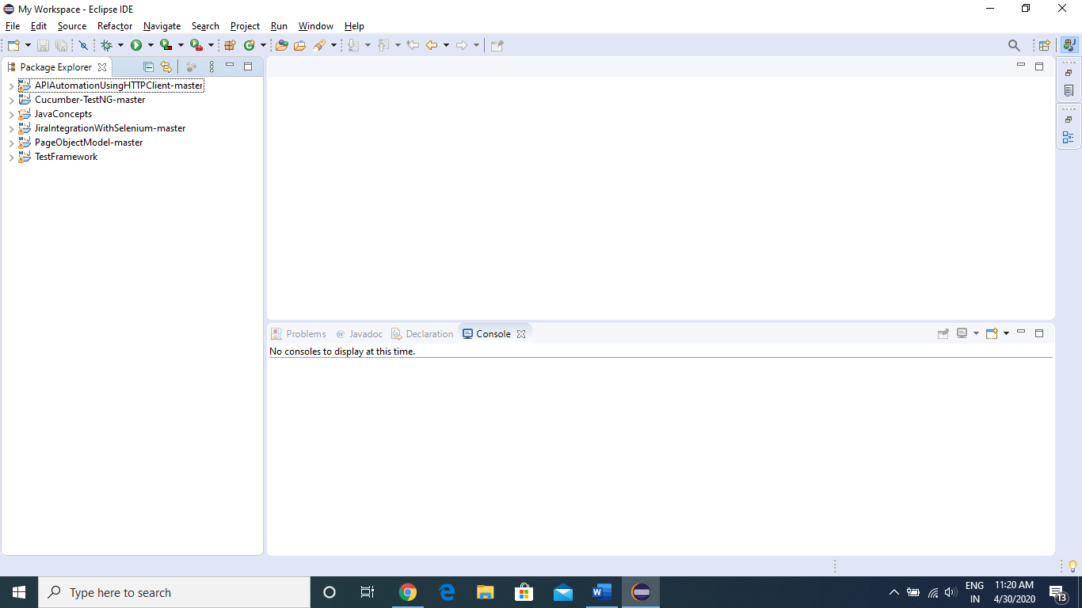

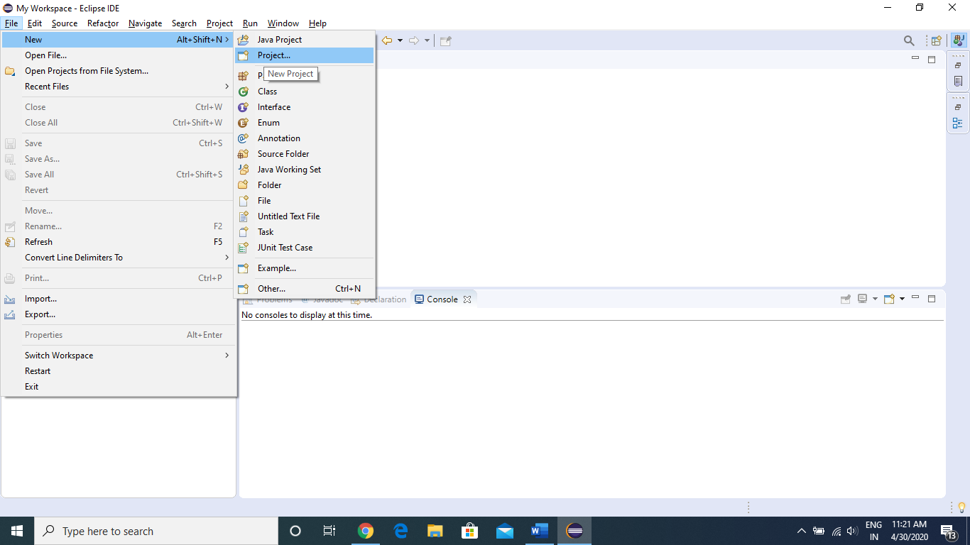

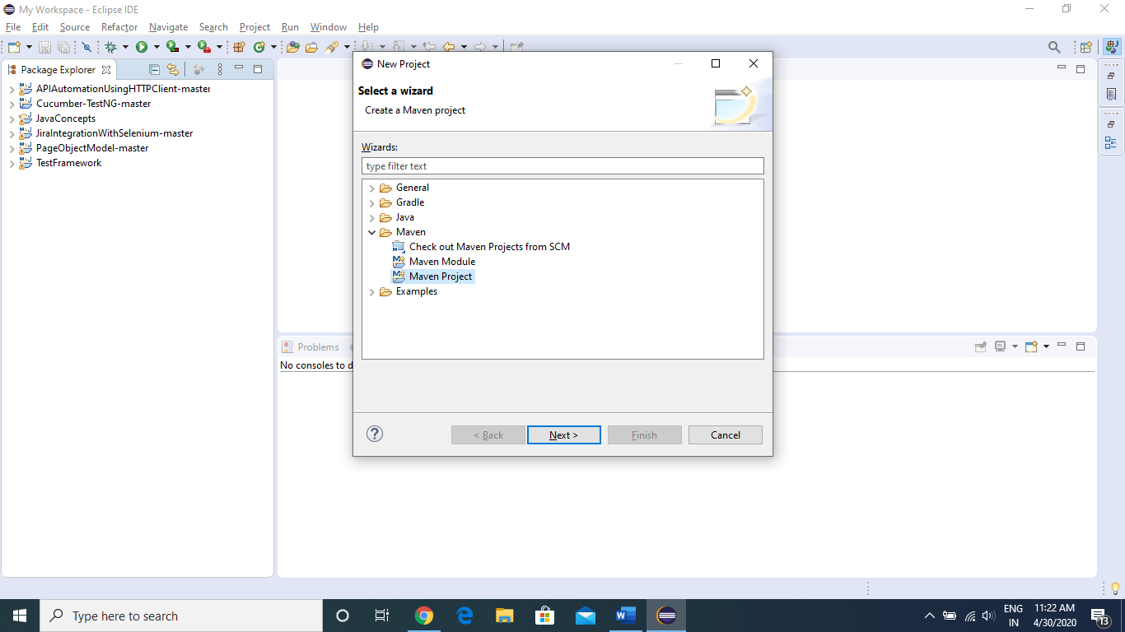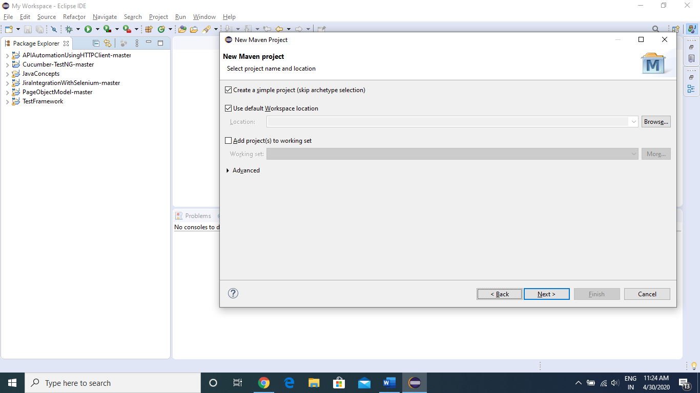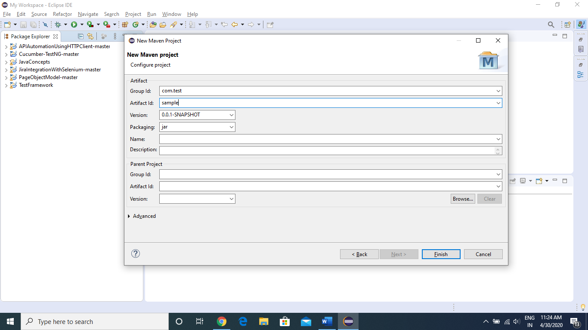

Now as you can see in below image, our **Sample maven project** is ready

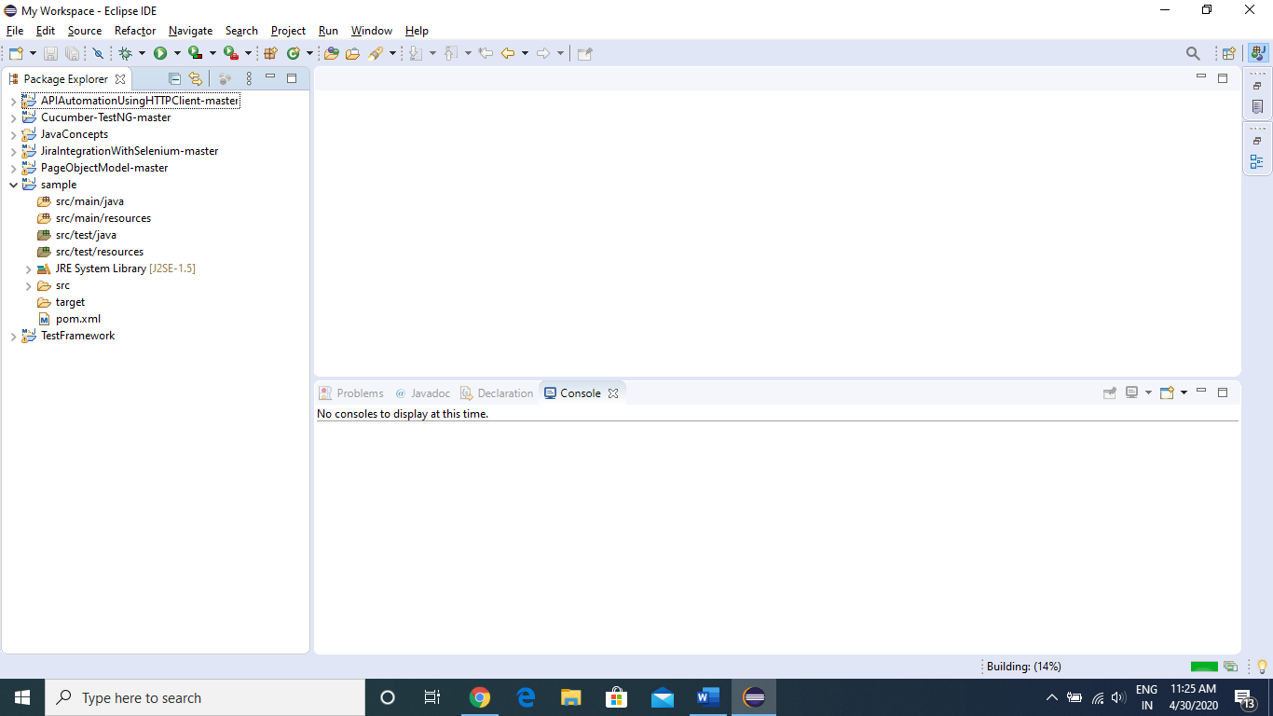

Now we will see how to add dependencies in our project.

Dependencies are the JAR files we need in our project, so as we are working on Selenium, we require Selenium jar file.

To get Selenium Jar dependency, we will go to below website.

<https://mvnrepository.com/>

Search for “Selenium JAVA” in the above website

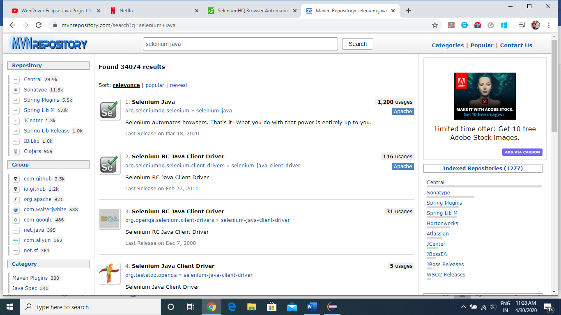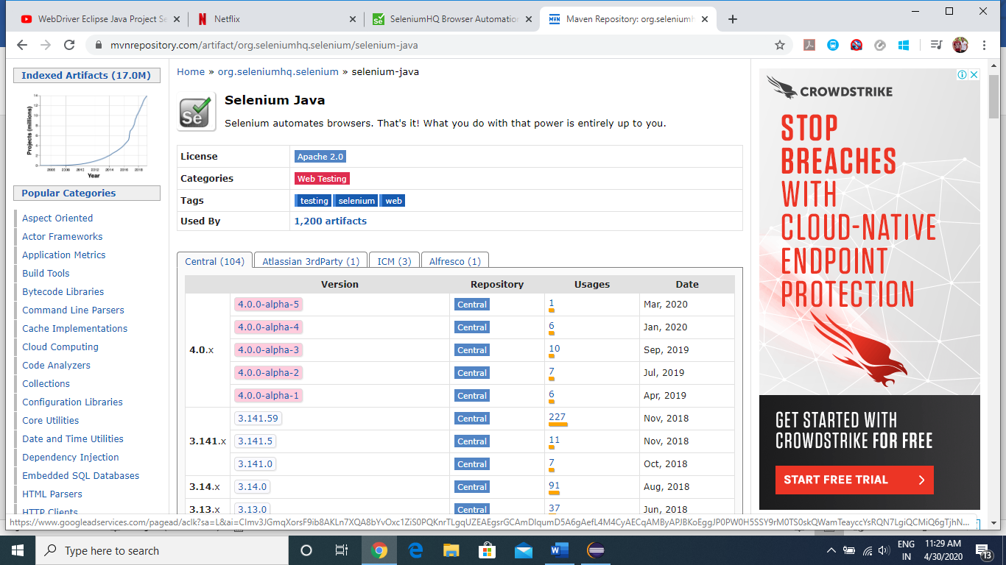

We will be using the stable version of selenium, which is **3.141.59**

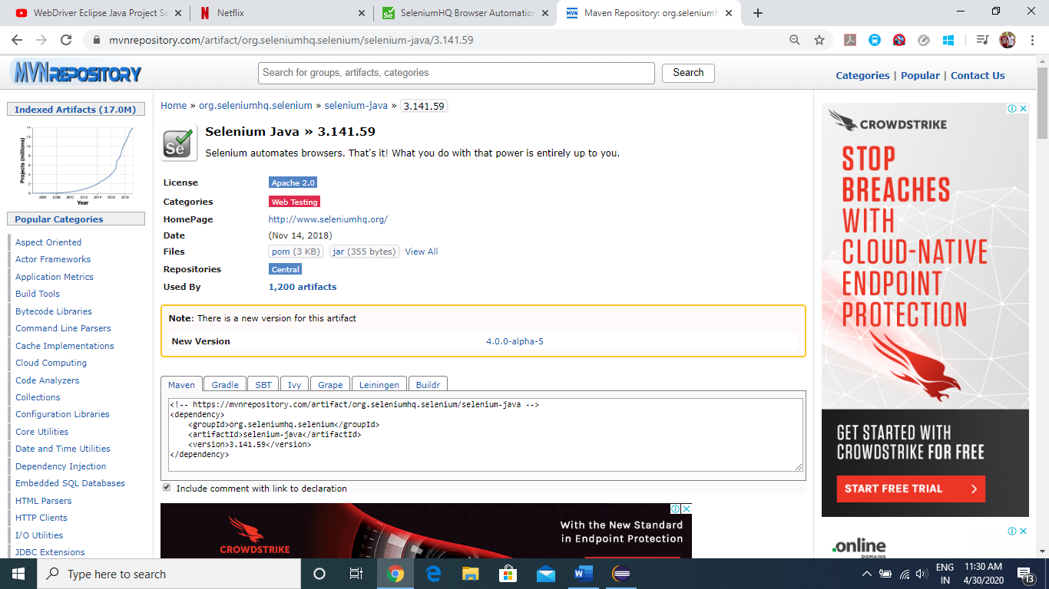

Just Copy the code from Maven tab as show below

<!-- https://mvnrepository.com/artifact/org.seleniumhq.selenium/selenium-java -->

<dependency>

<groupId>org.seleniumhq.selenium</groupId>

<artifactId>selenium-java</artifactId>

<version>3.141.59</version>

</dependency>

Now we will go back to our Sample project in Eclipse and open POM.xml file

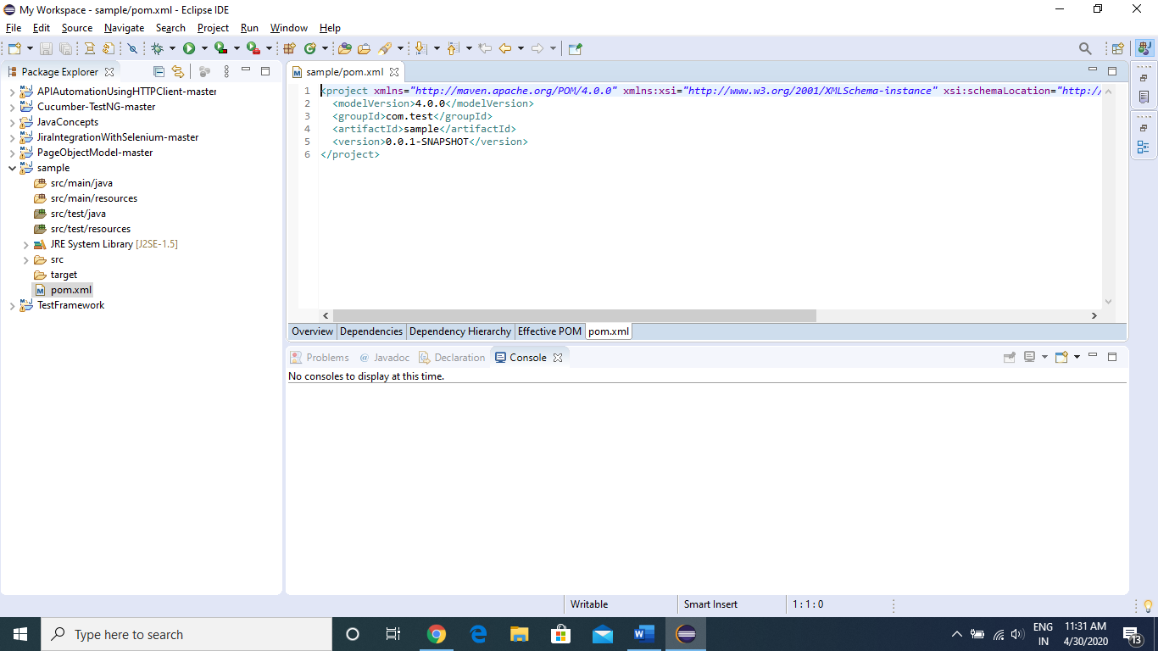

Now paste the dependency here inside <dependencies></dependencies> tag and save it (ctrl +s)

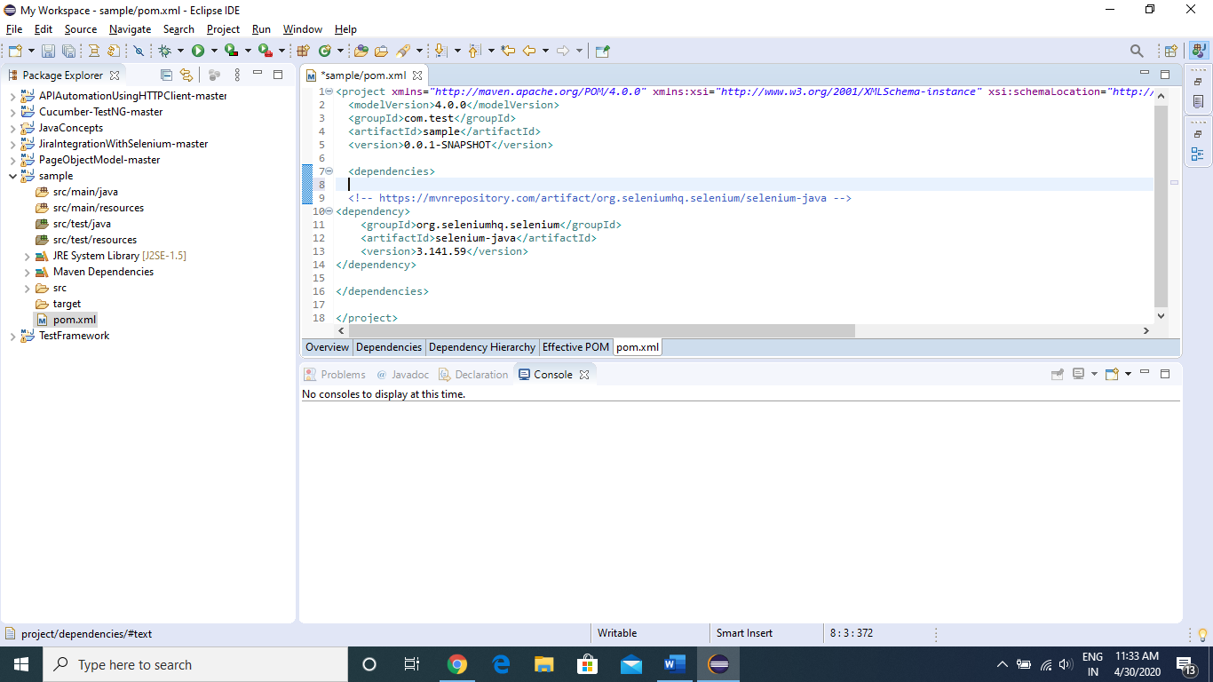

Now we will see, in the Project Explorer panel, “Maven Dependencies” have been created and inside it, all the required selenium jar files are imported.

Now we are ready to test some webpage

To do so, we will be creating a Java class inside **src/test/java** folder

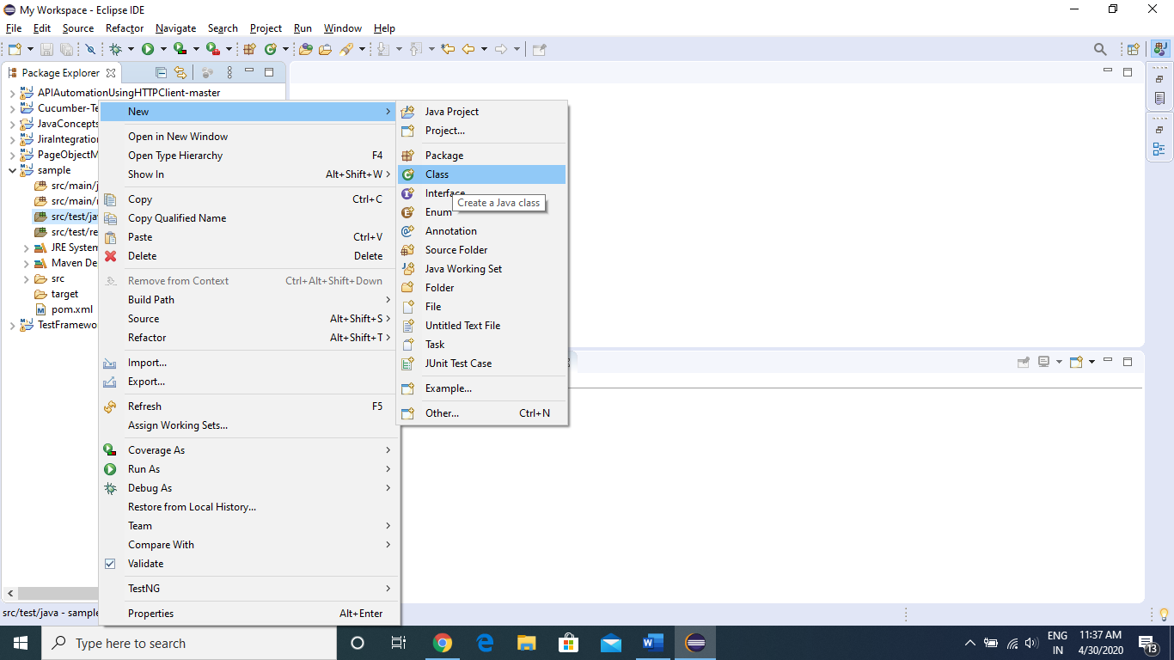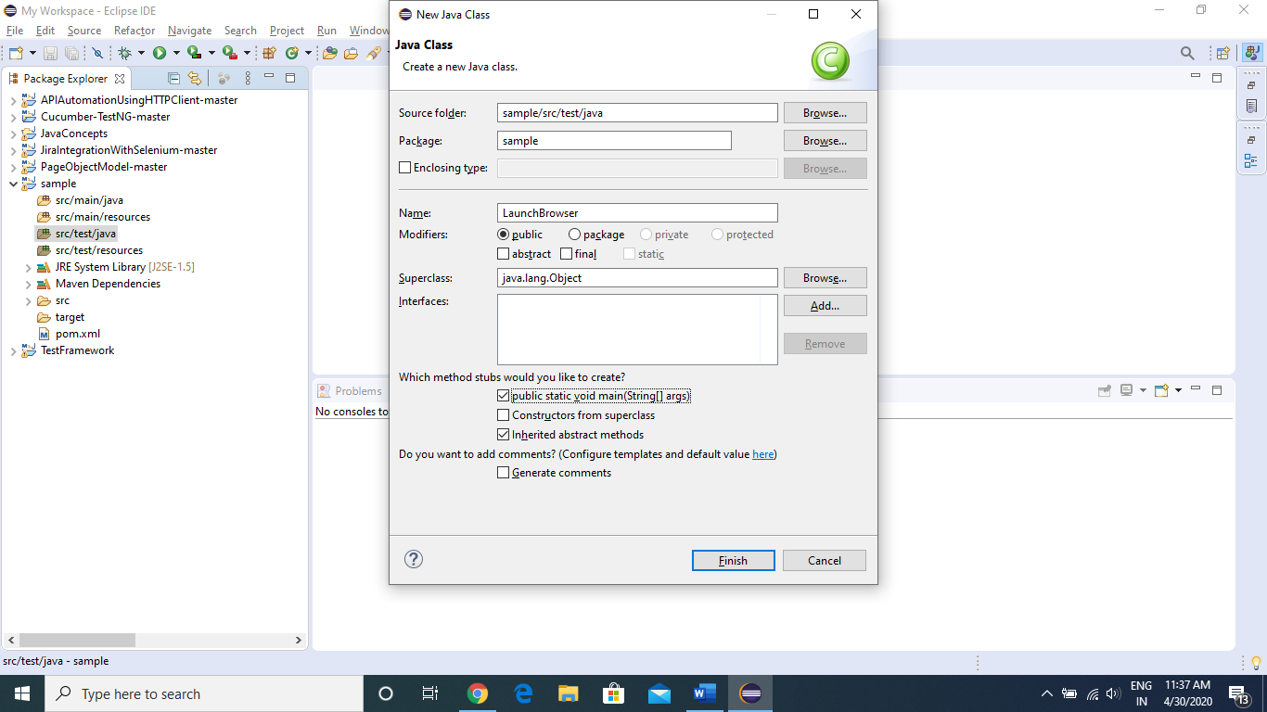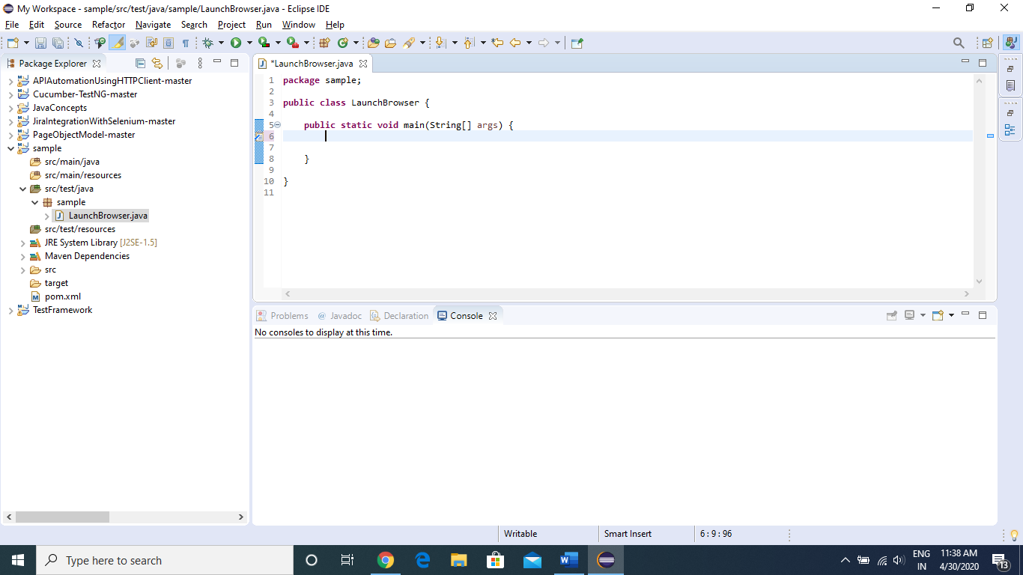

Now as we are going to work with Chrome browser, we will be downloading chrome driver executable file from “<https://chromedriver.chromium.org/downloads>”

**NOTE**: Please download the driver file according to the chrome version installed in your machine

Now go back to your project in Eclipse and start coding.

Code to Launch a URL in browser and get the title of page

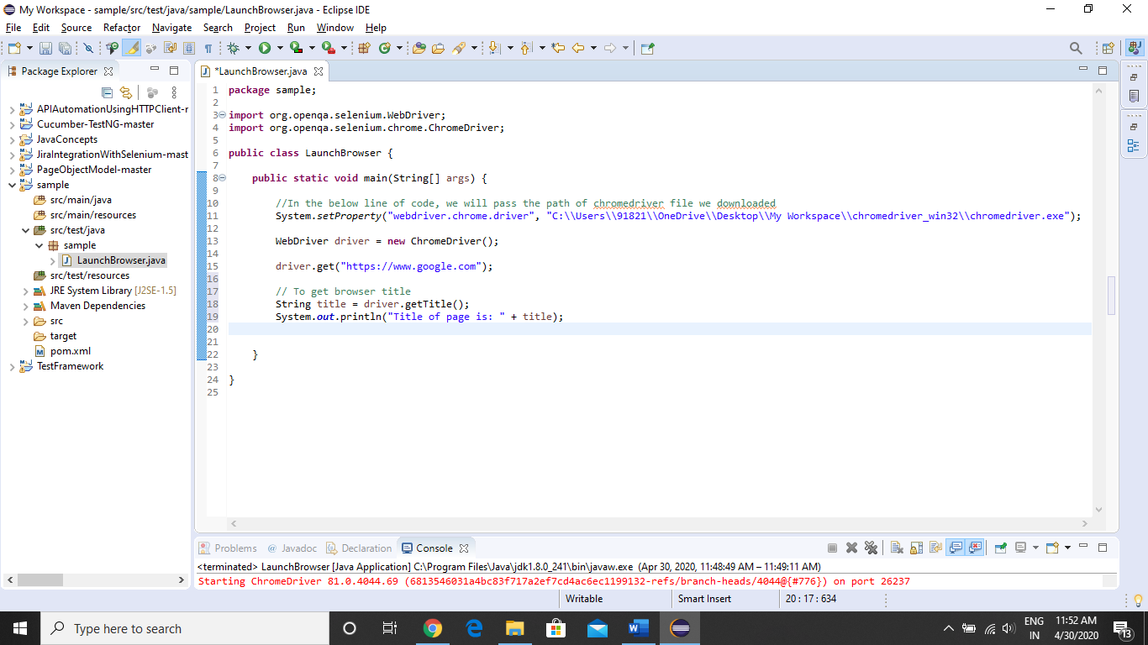

Now execute the above code

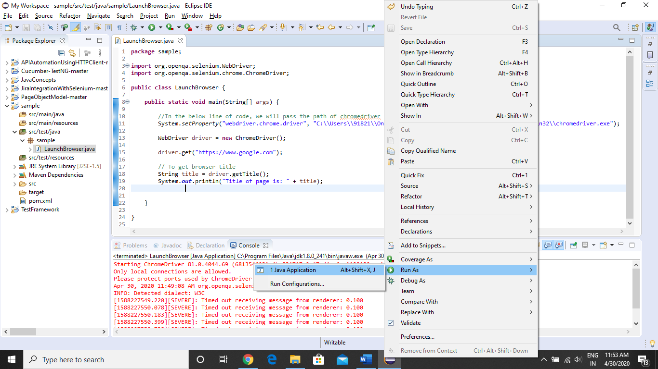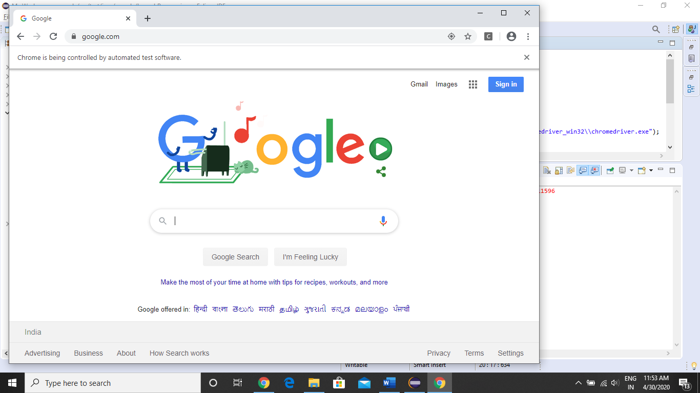

As we can see, in console tab, we are getting the title of the page

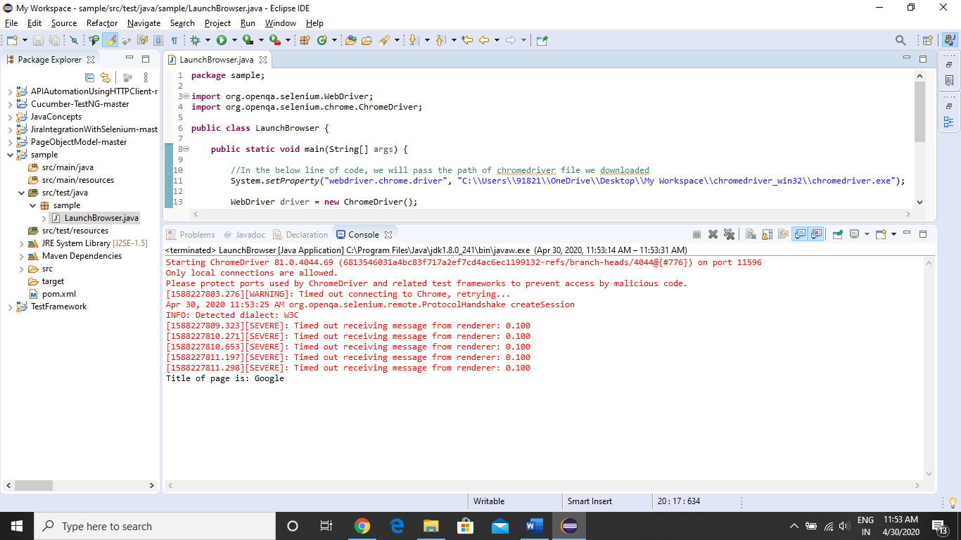

Now we will see, how to perform actions on Webpage elements

To perform some actions, we need some property of that element.

Elements can be text fields, dropdowns, radio button, check box, buttons, links, etc.…

To create XPATH or to capture some properties of element we have to use “Inspect Element” feature of google chrome web browser

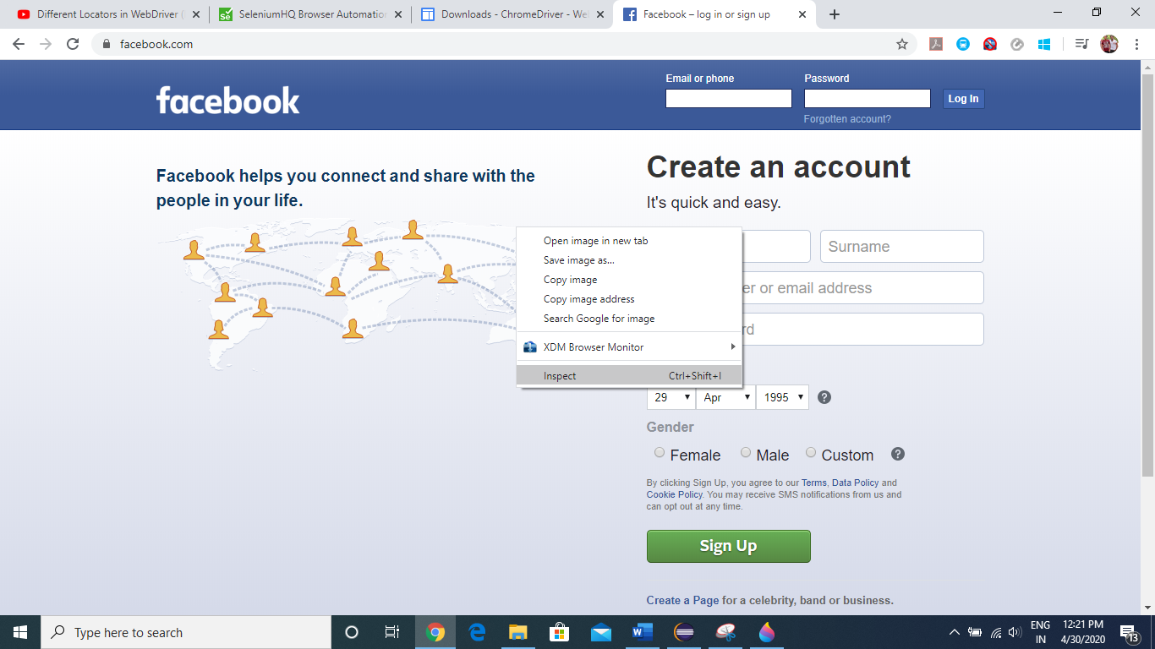

To Select the element in the page to inspect it, click the below button

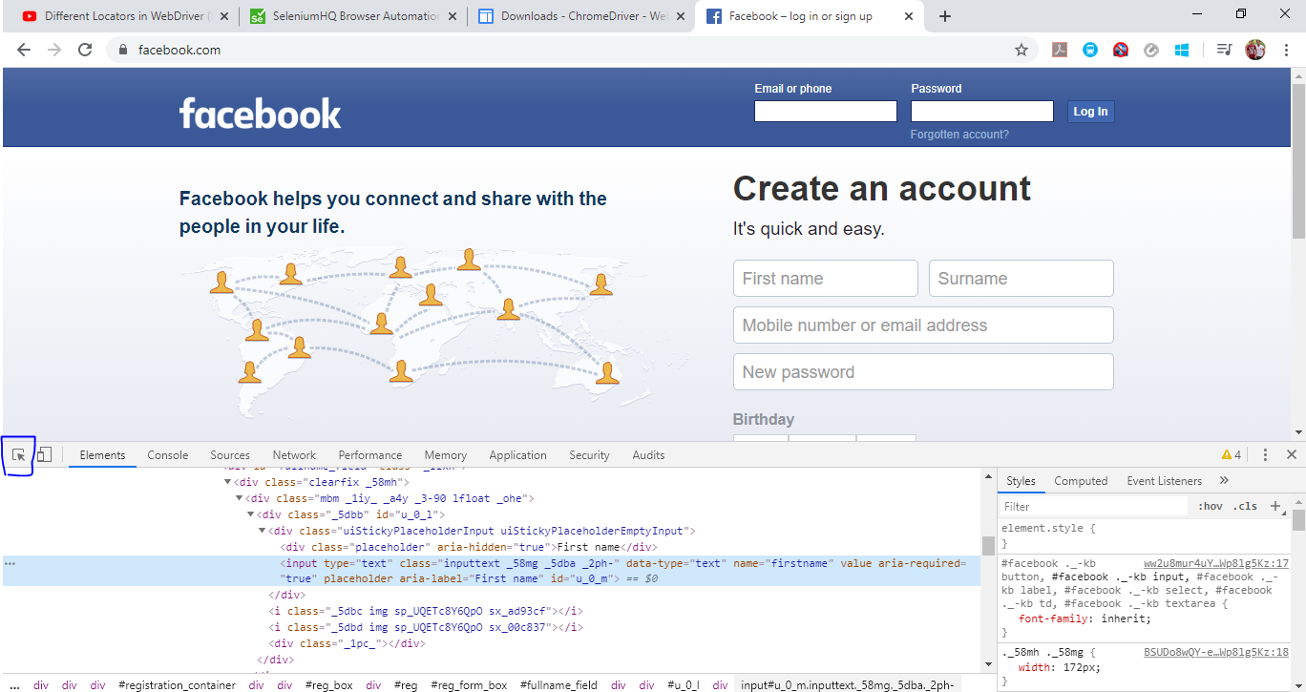

Now click on whatever element you want to inspect, here we are taking “First Name” text box as out element

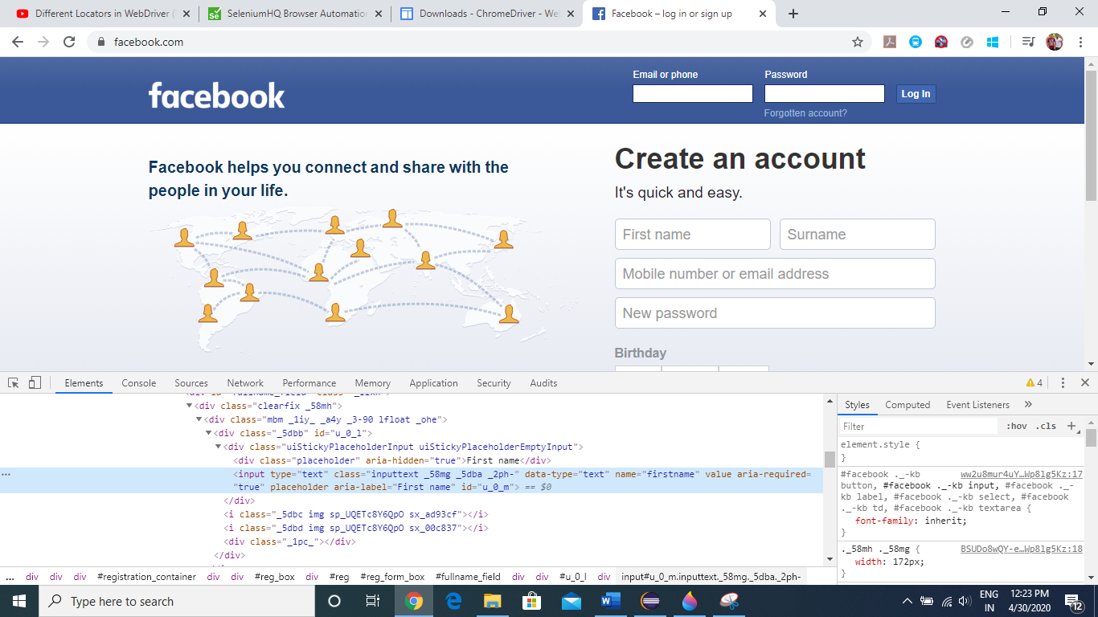

Now as we can see, once we click on the text box, we will get the properties of our test box under elements tab.

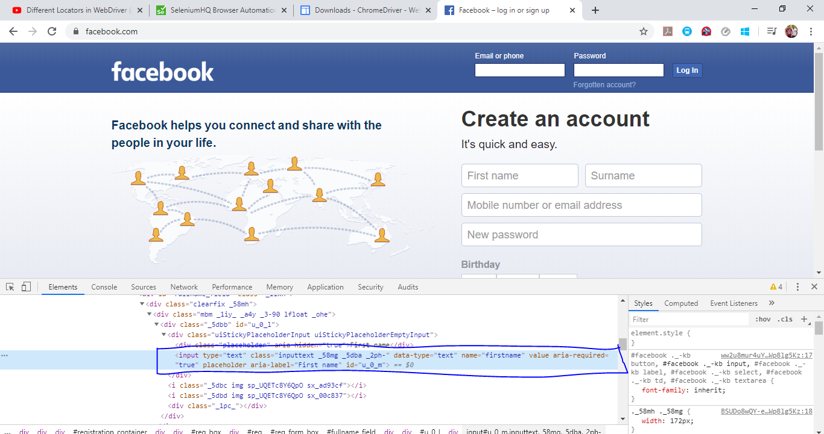

From here we will use whatever property we require to create our locators.

Now we will go to “Facebook.com” and try to enter “First Name” via **XPATH** (Locators)

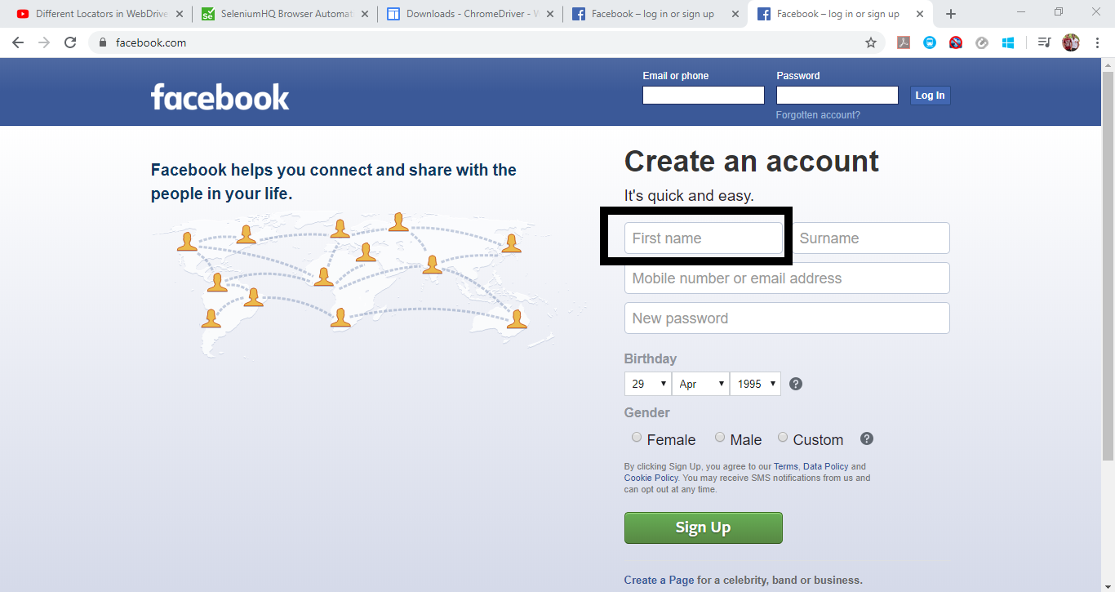

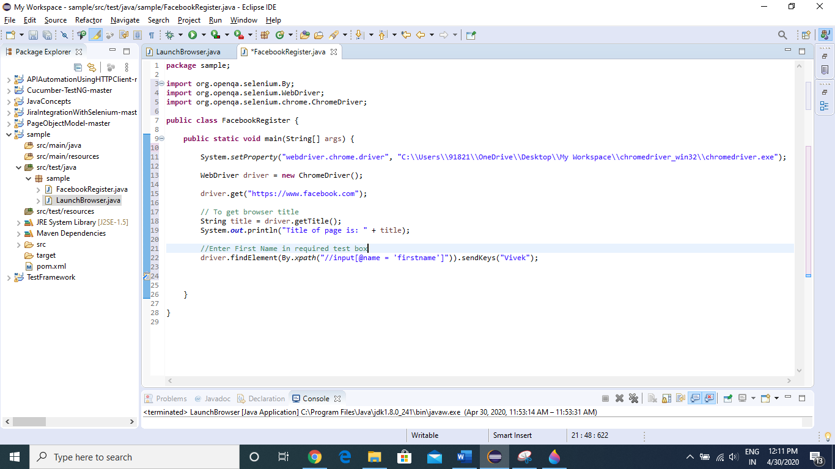

In Console, we can see title of page is printed, and in Webpage, First Name is filled successfully.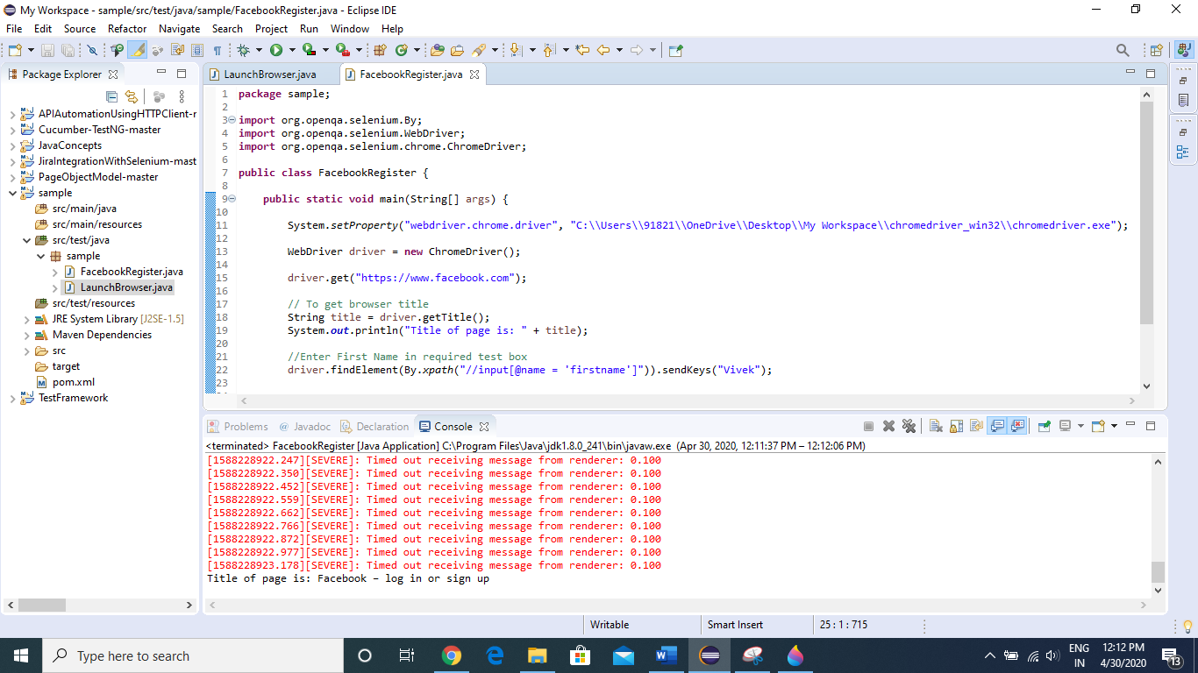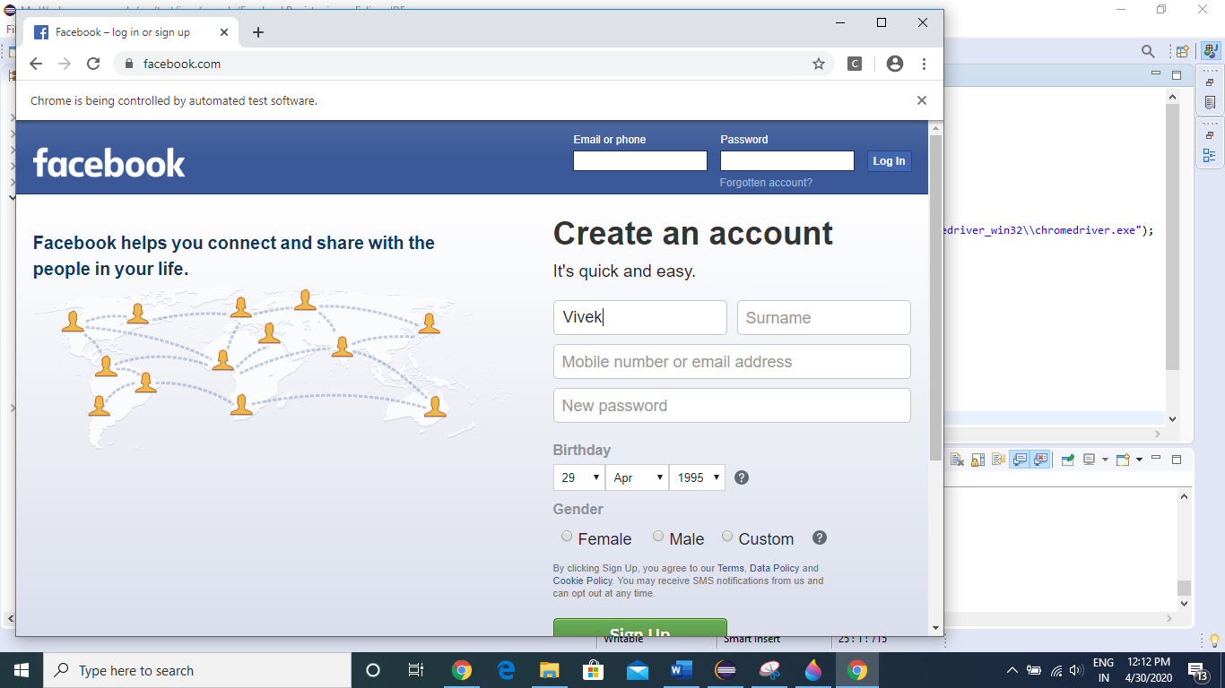

Now we will enter Surname using **ID** (Locators)

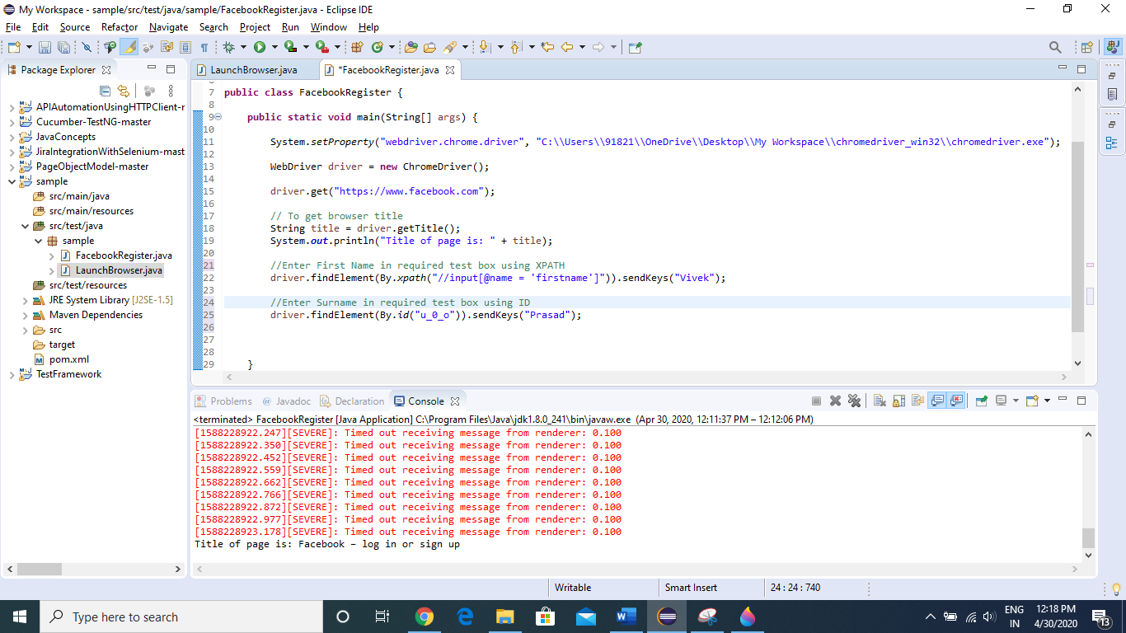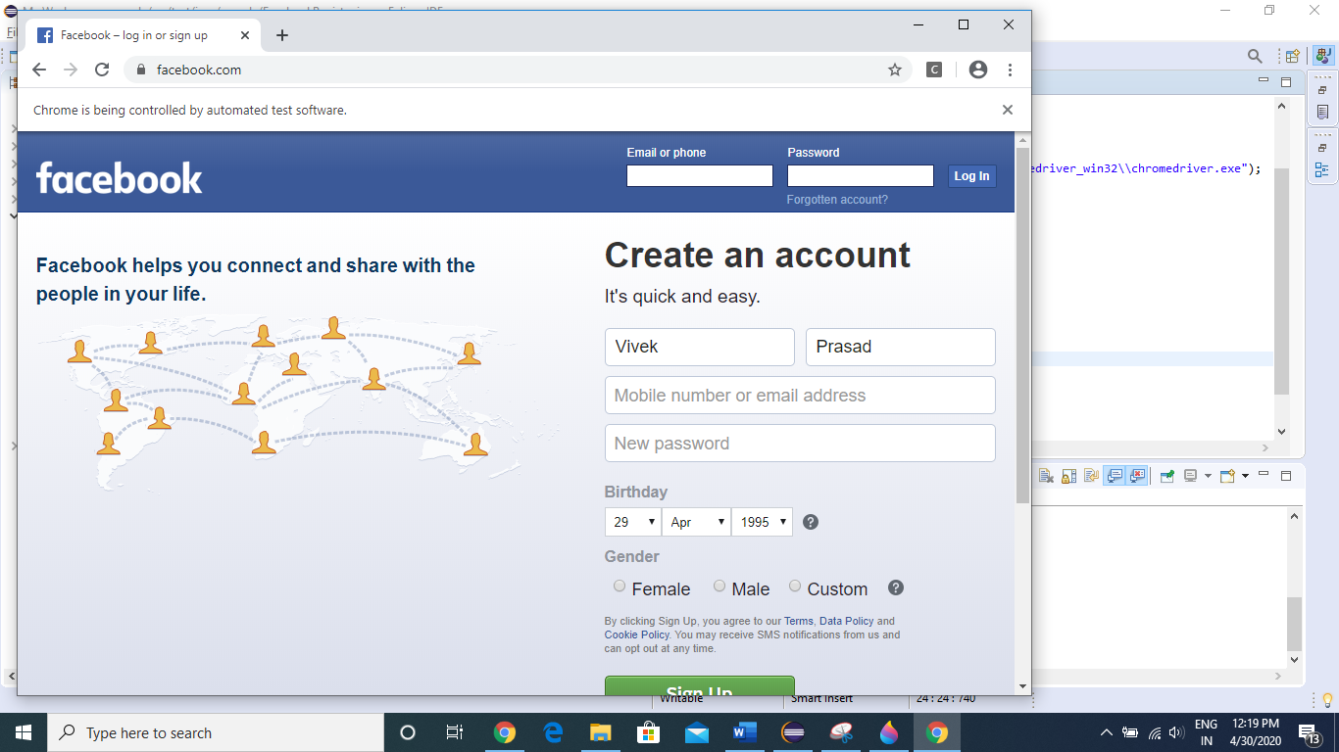

There are total 8 types of locators, based on the element property we have to determine which locator to use for a particular action.

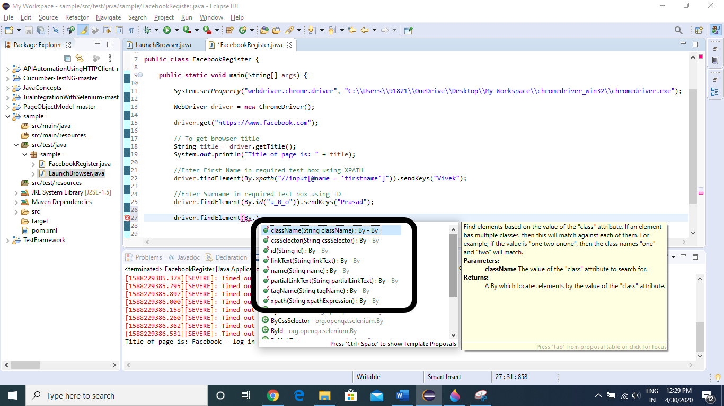

Now we will see how to use different locators

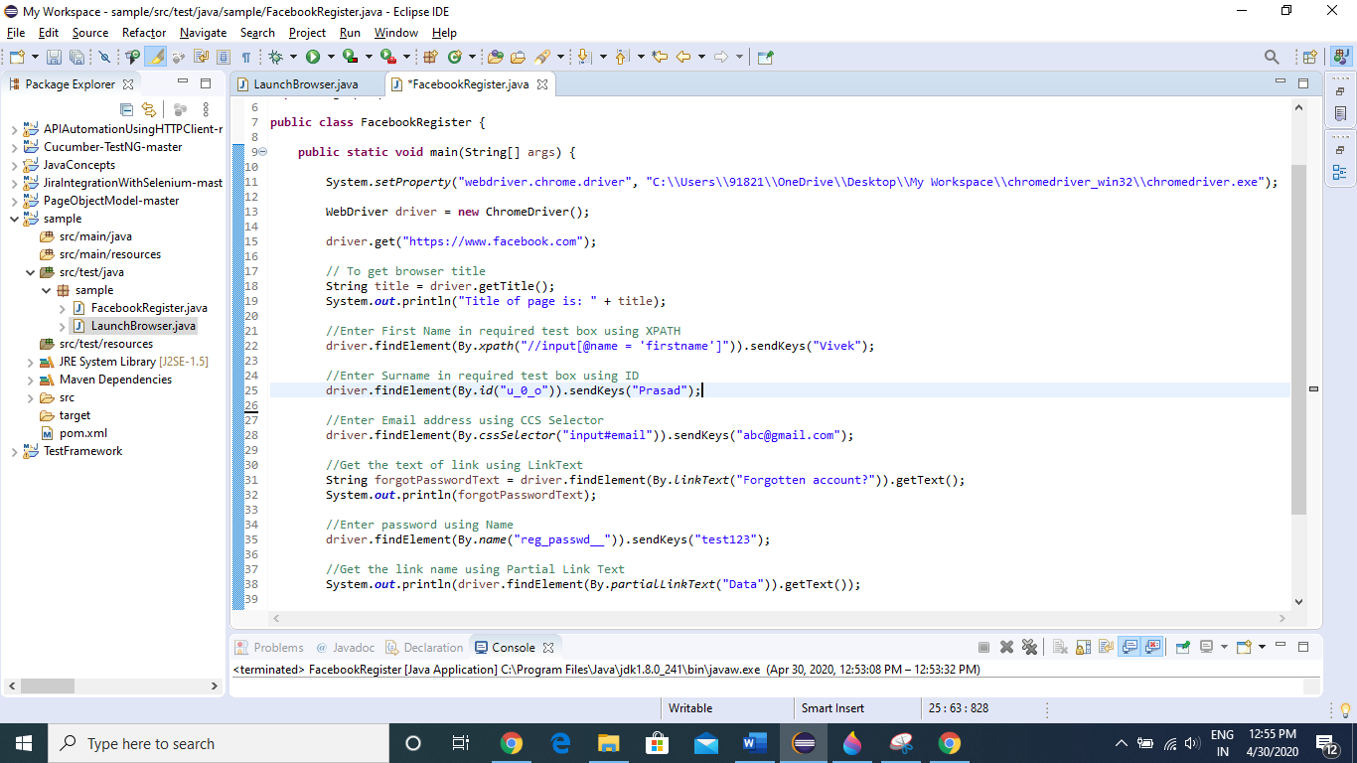

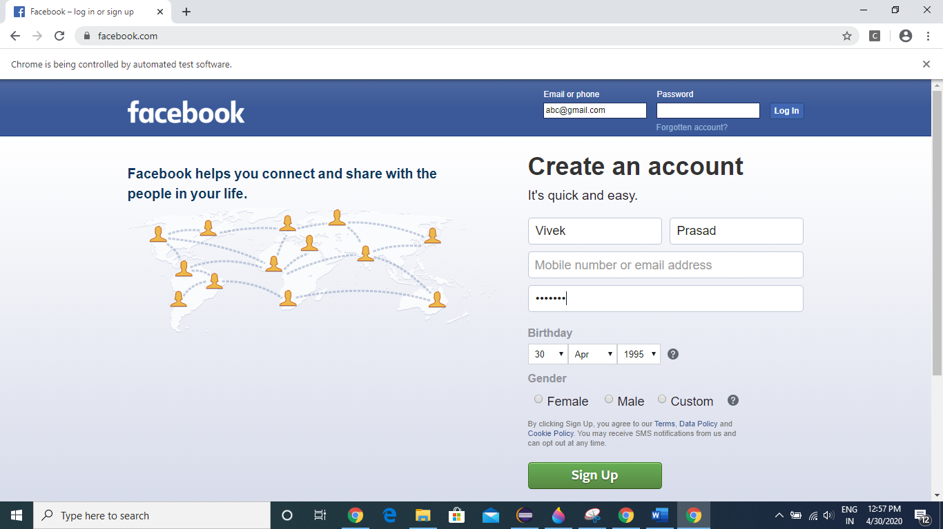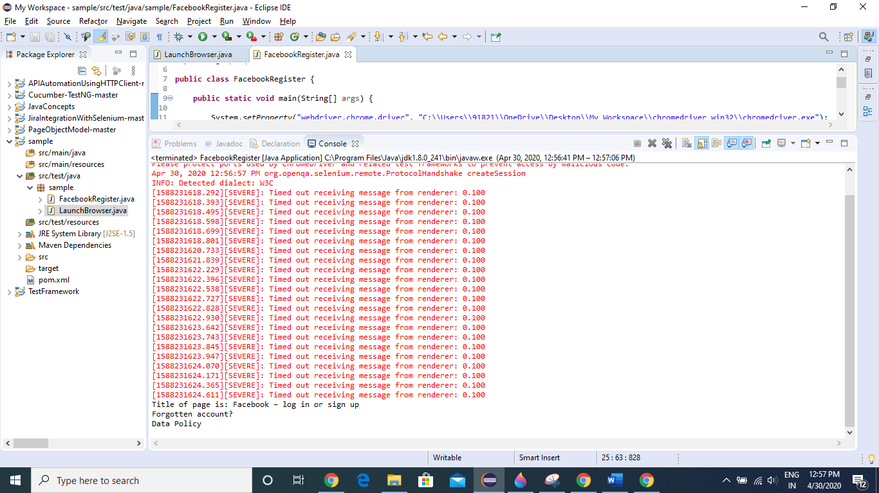

Now we will see how to handle Dropdowns.

We can handle dropdowns using SELECT class

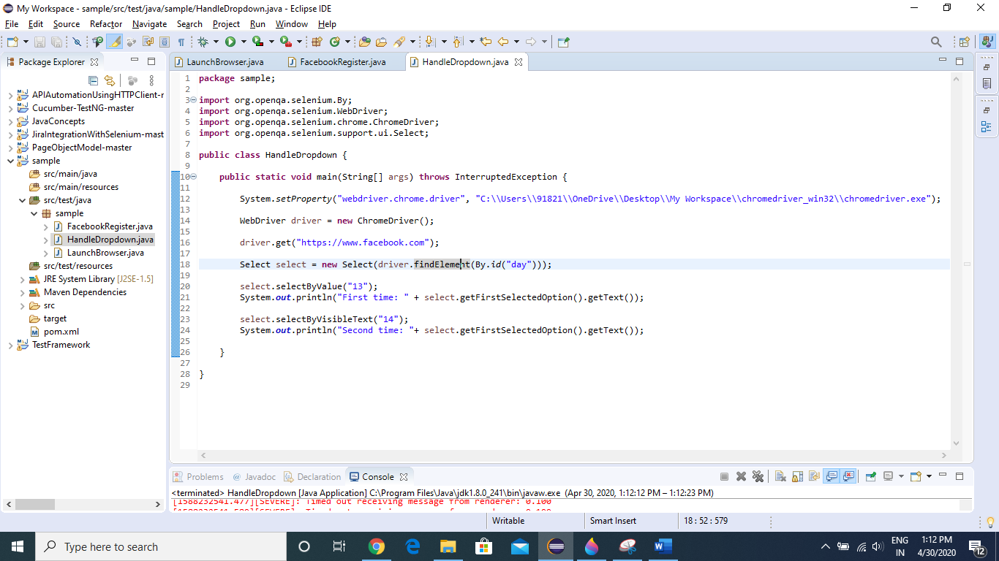

First time it will select 13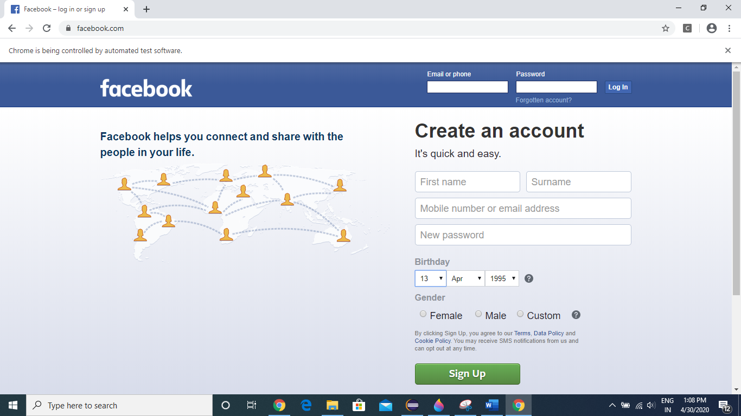

Second time it will select 14

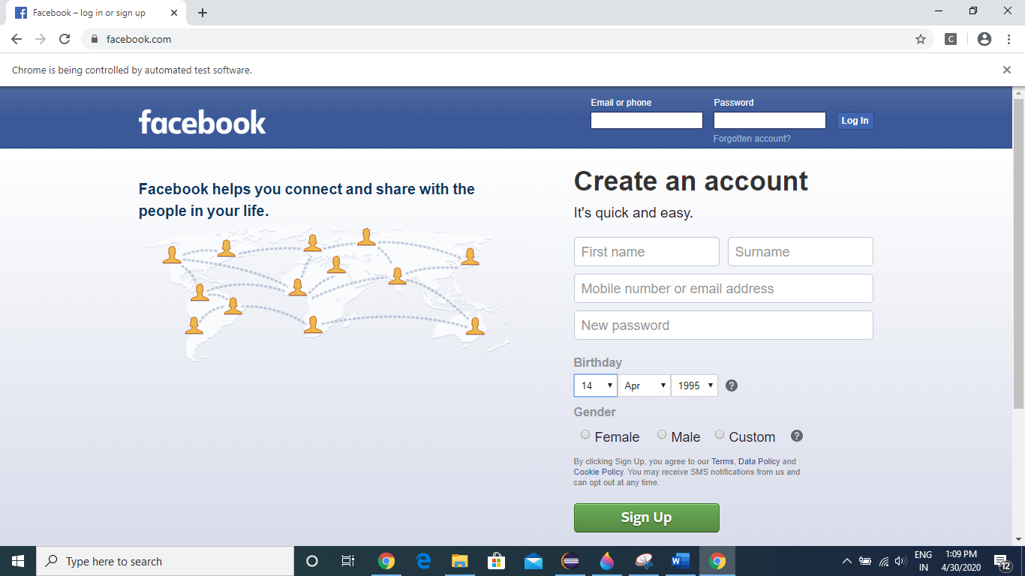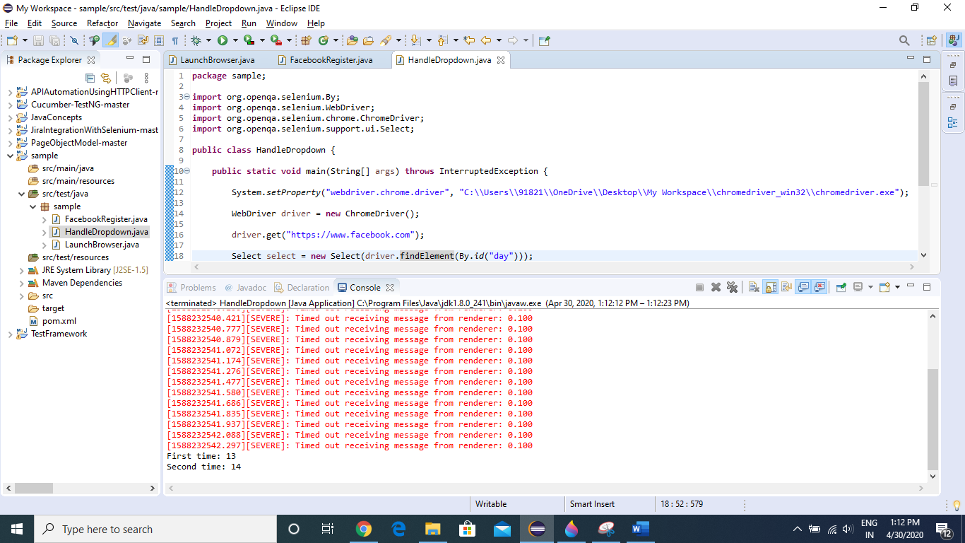

Now we will see how to handle JavaScript Popups /Alerts.

We cannot inspect this “OK” button.

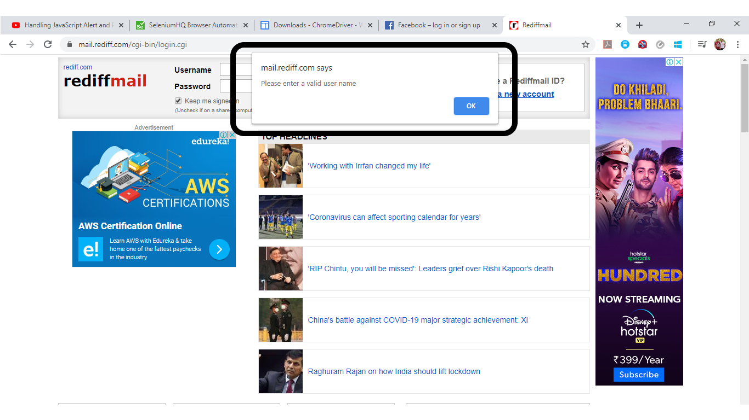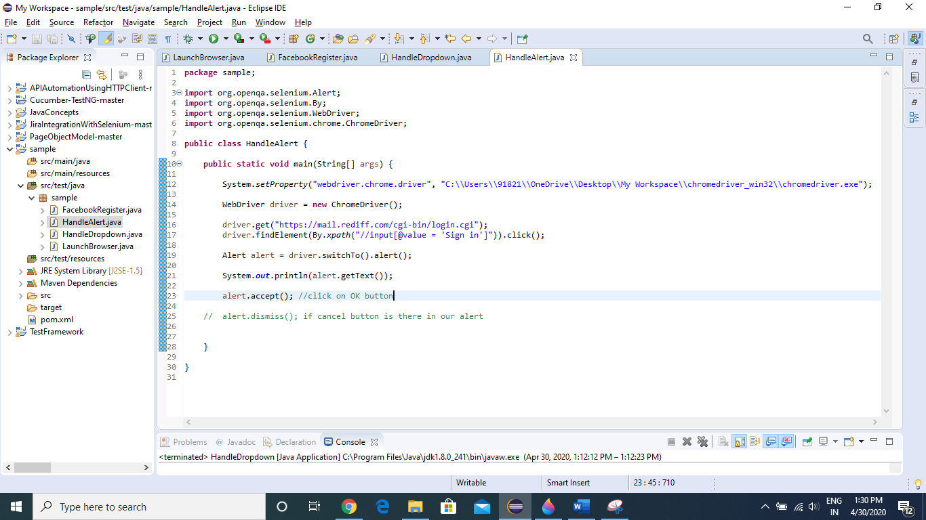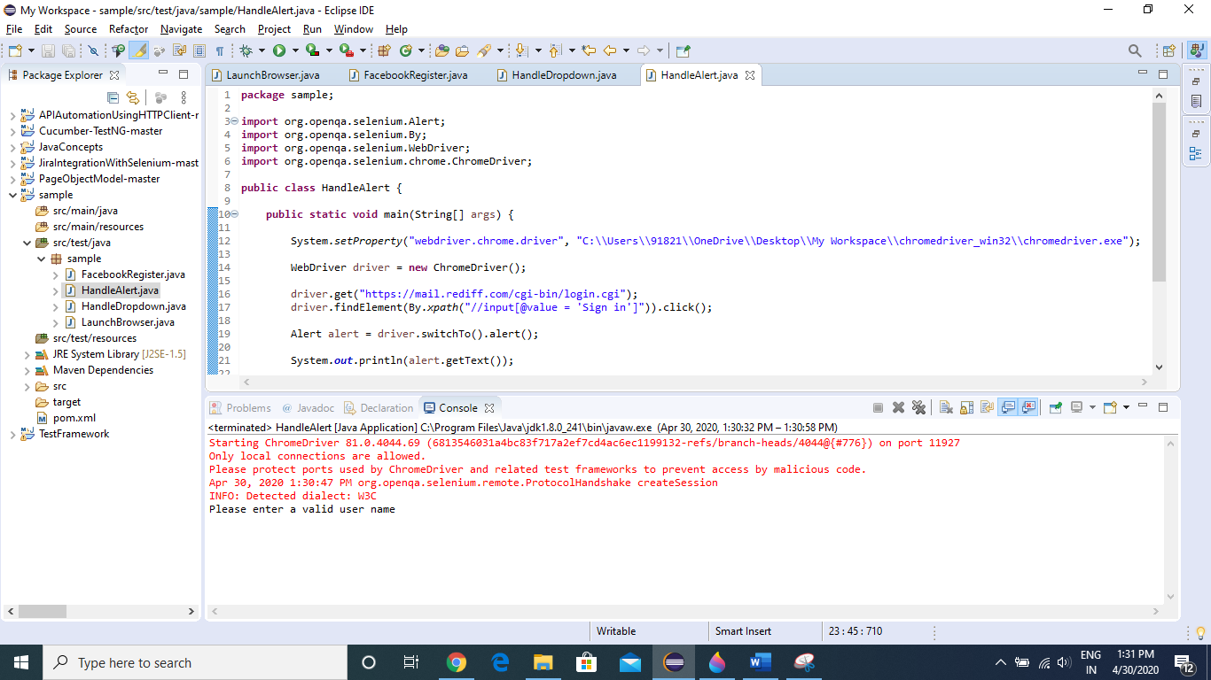

Now we will see how to upload a file in a webpage

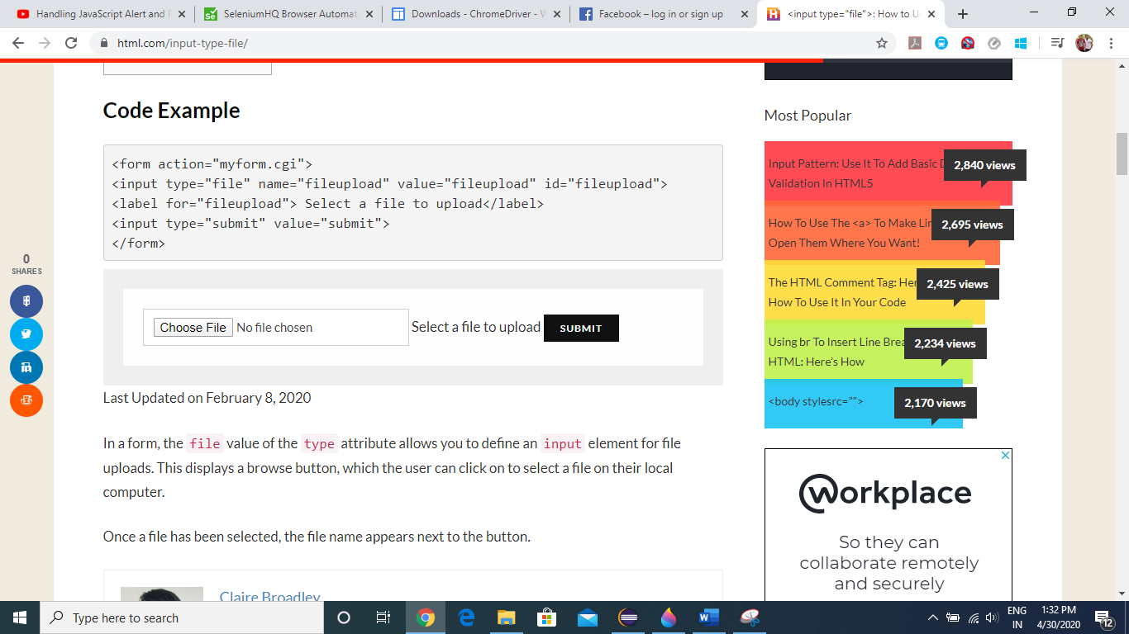

Once we click “Choose File”, a window popup will open and it cannot be handled via selenium

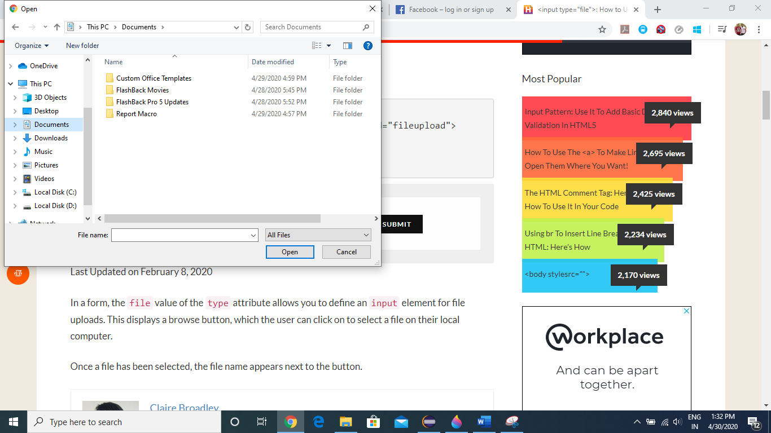

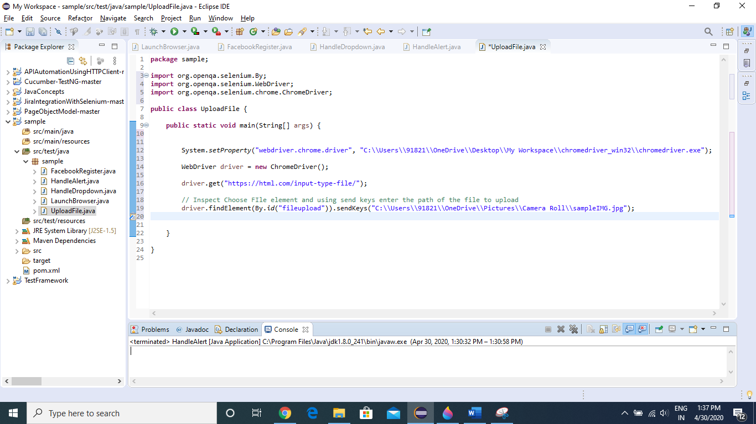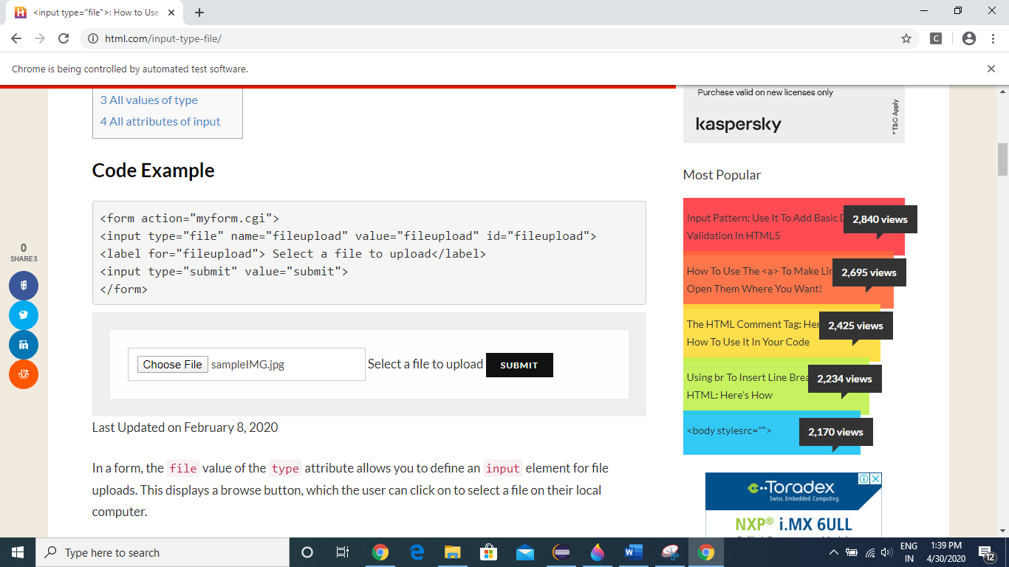

How to Handle FRAMES in a webpage

Sometimes we are getting error like element not found exception / unable to locate element, so there can be a reason that the element is present in particular frame.

The below webpage contains iframes.

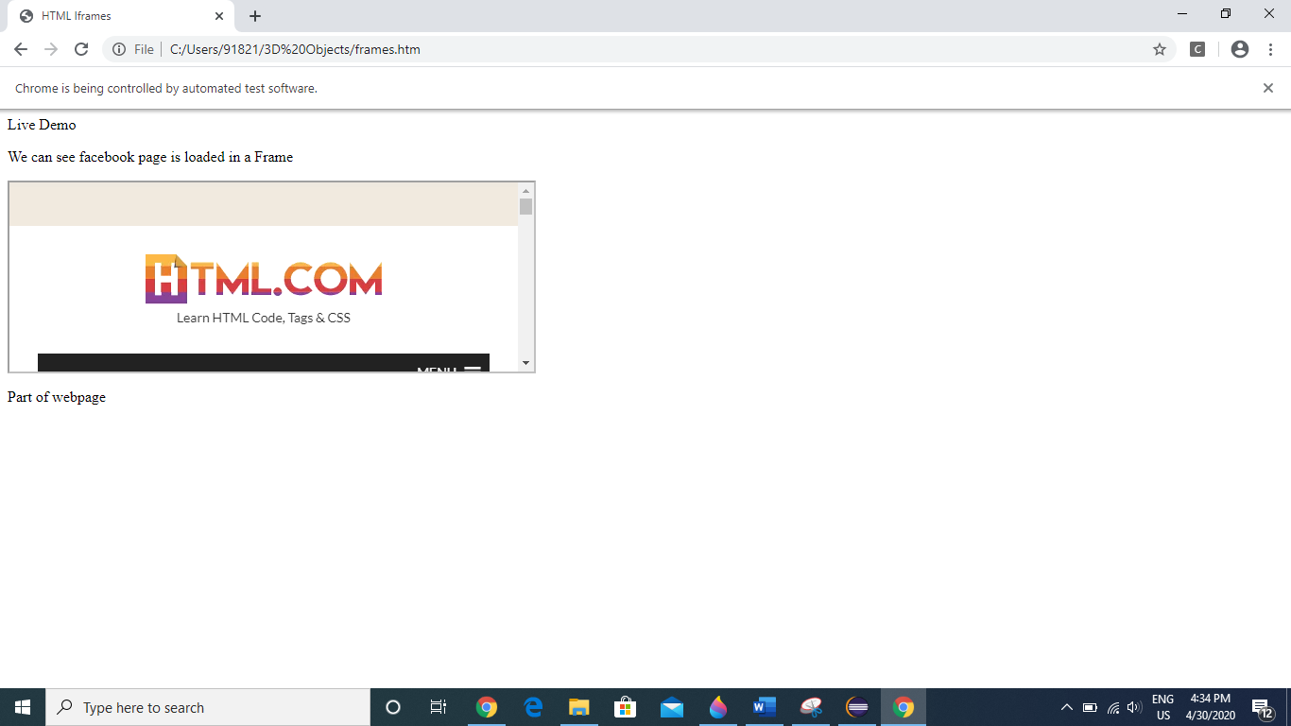

Now we will try to fetch the text “Learn HTML Code, Tags & CSS” directly via XPATH, as a result we will get “No Such Element Exception” because it is present under Frames.

Now we will try to access this part using frame handling method

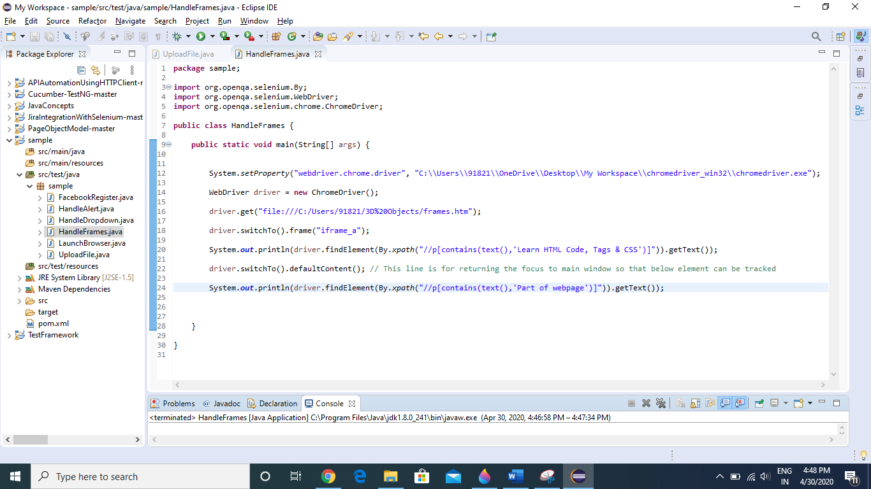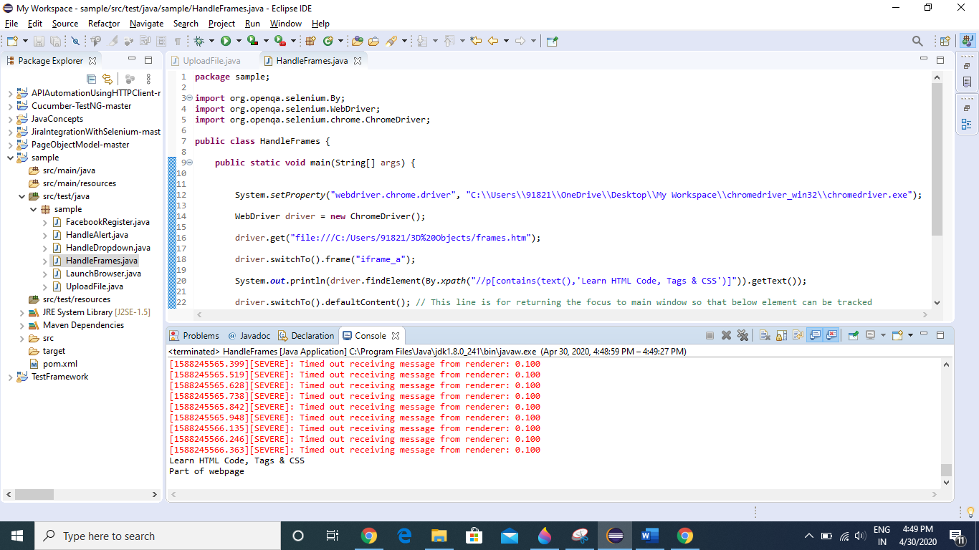

How to Move hover to certain element in a webpage

Once we moreover to “Add Ons” link in menu, we get this sub menu, but as soon as the position of cursor changes the menu closes.

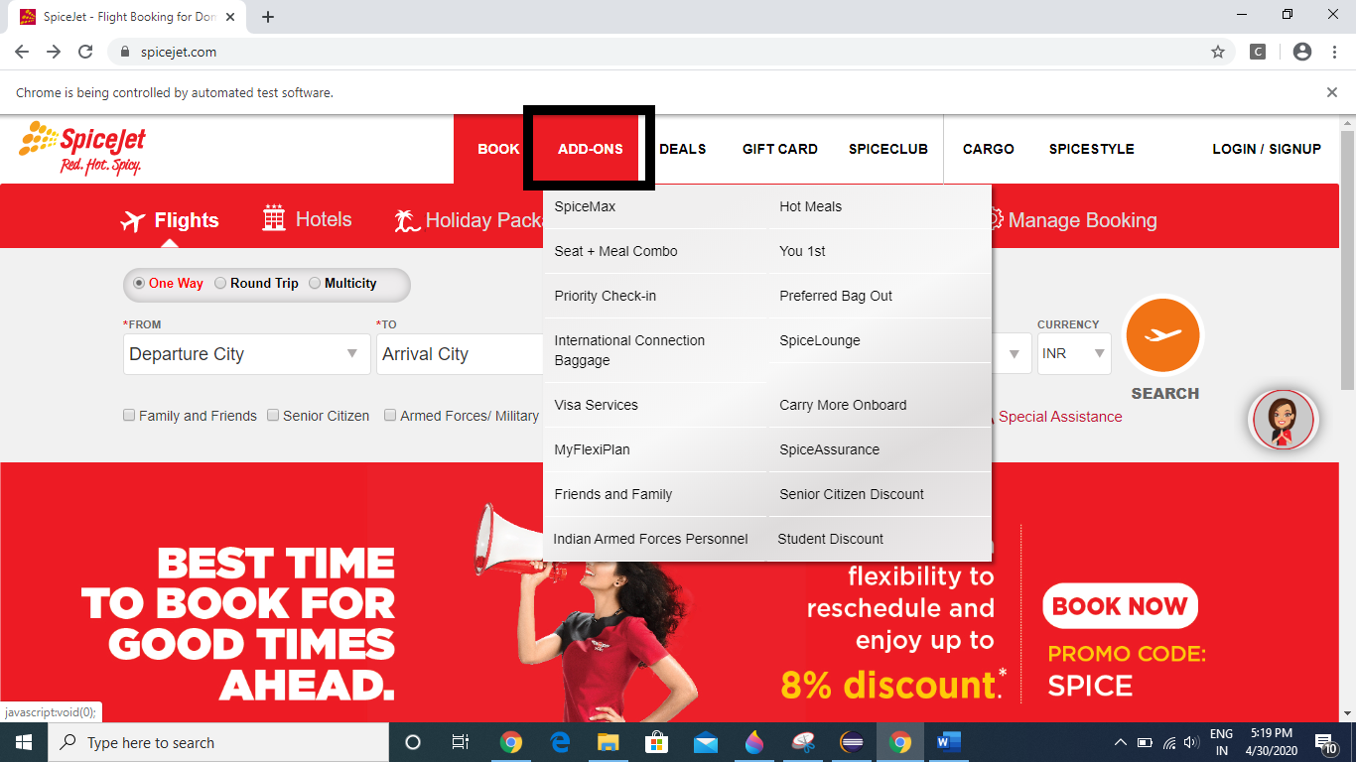

So, lets see how to handle this type of scenario.

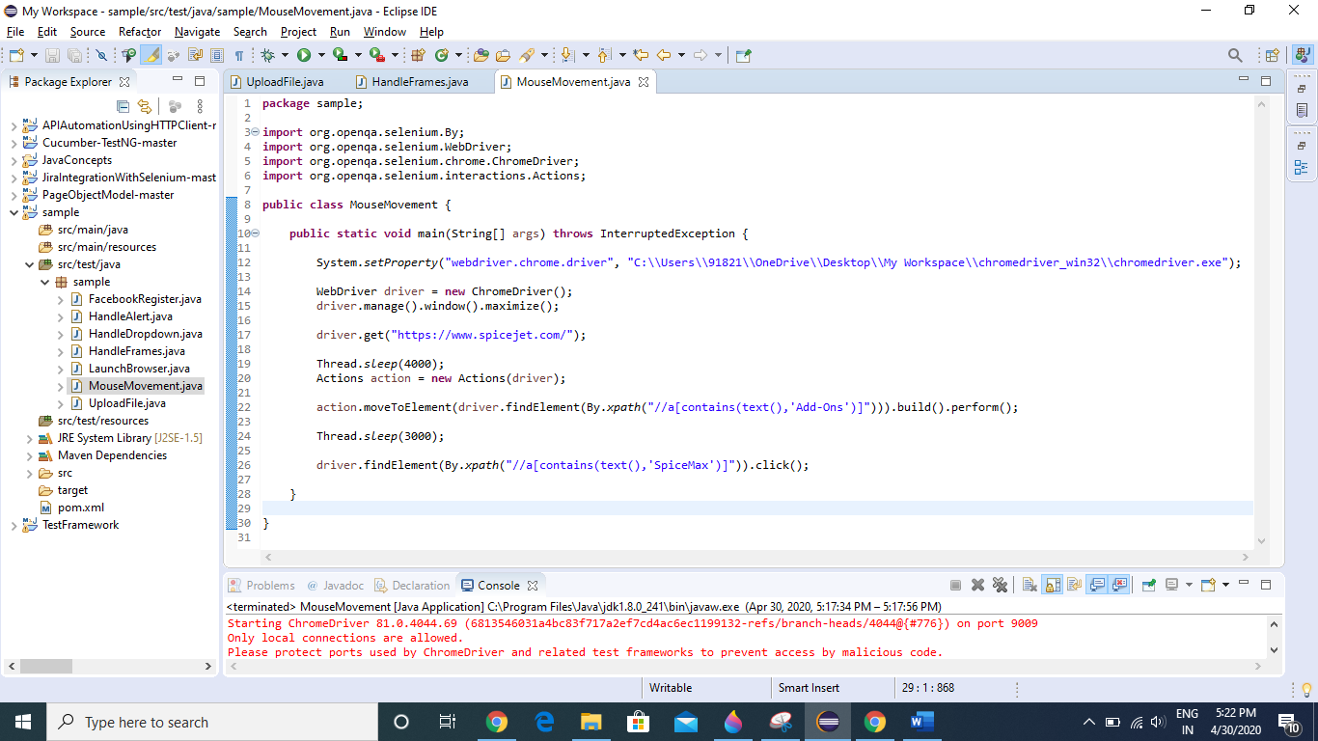

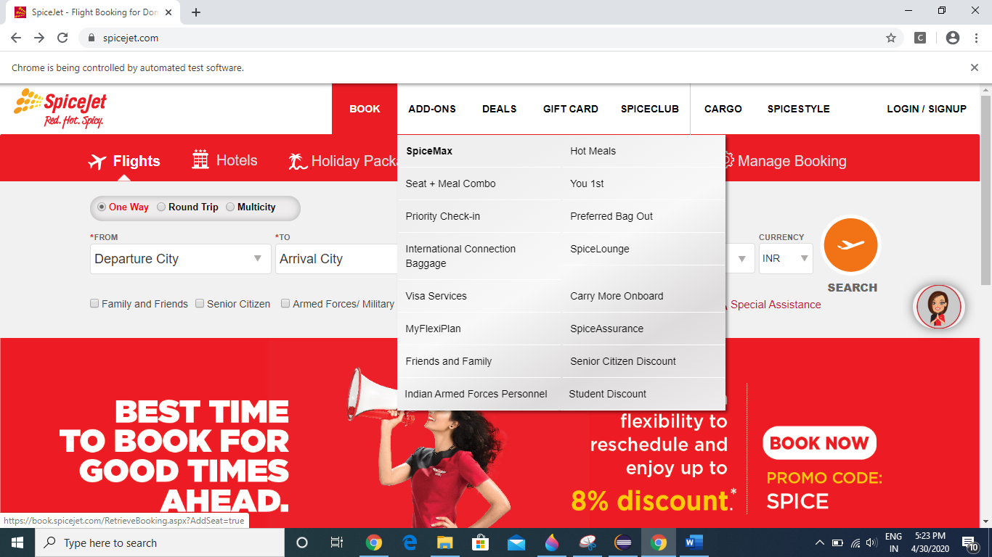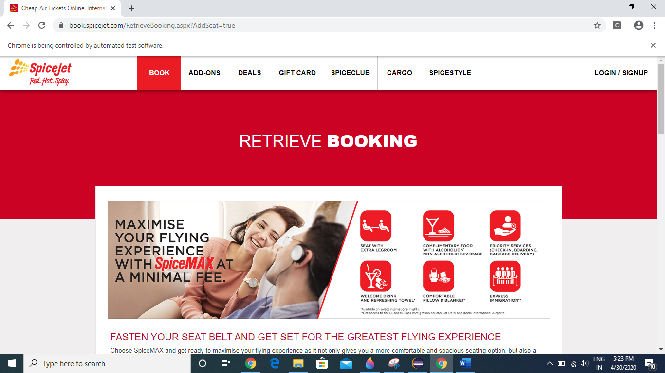

Perform Drag and Drop in webpage

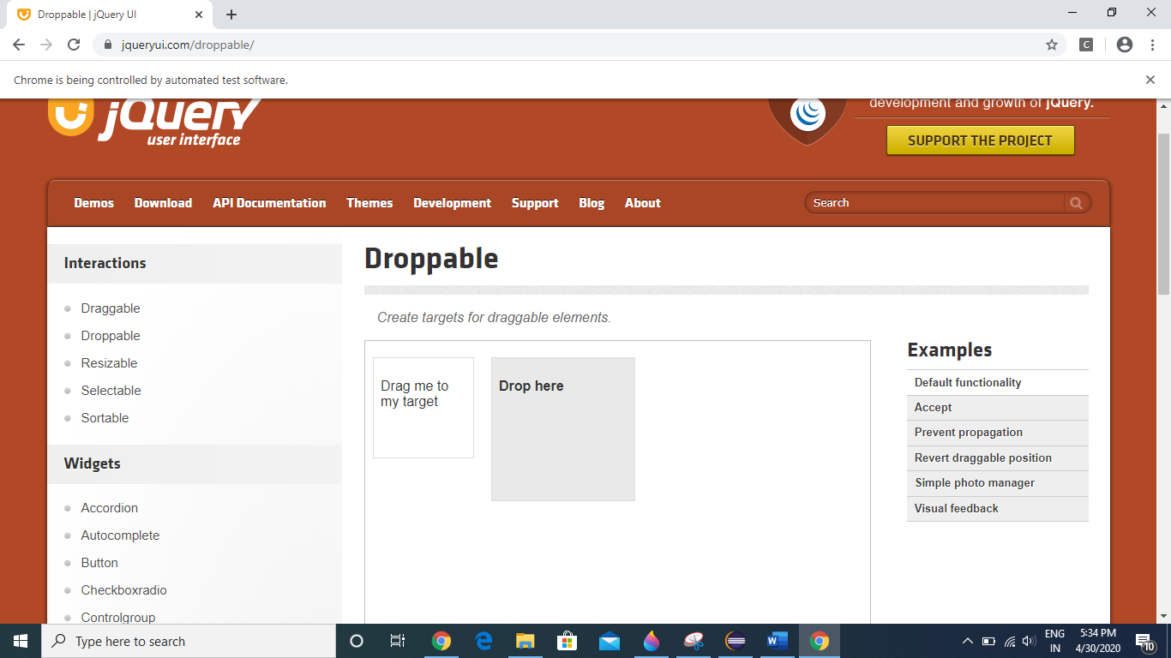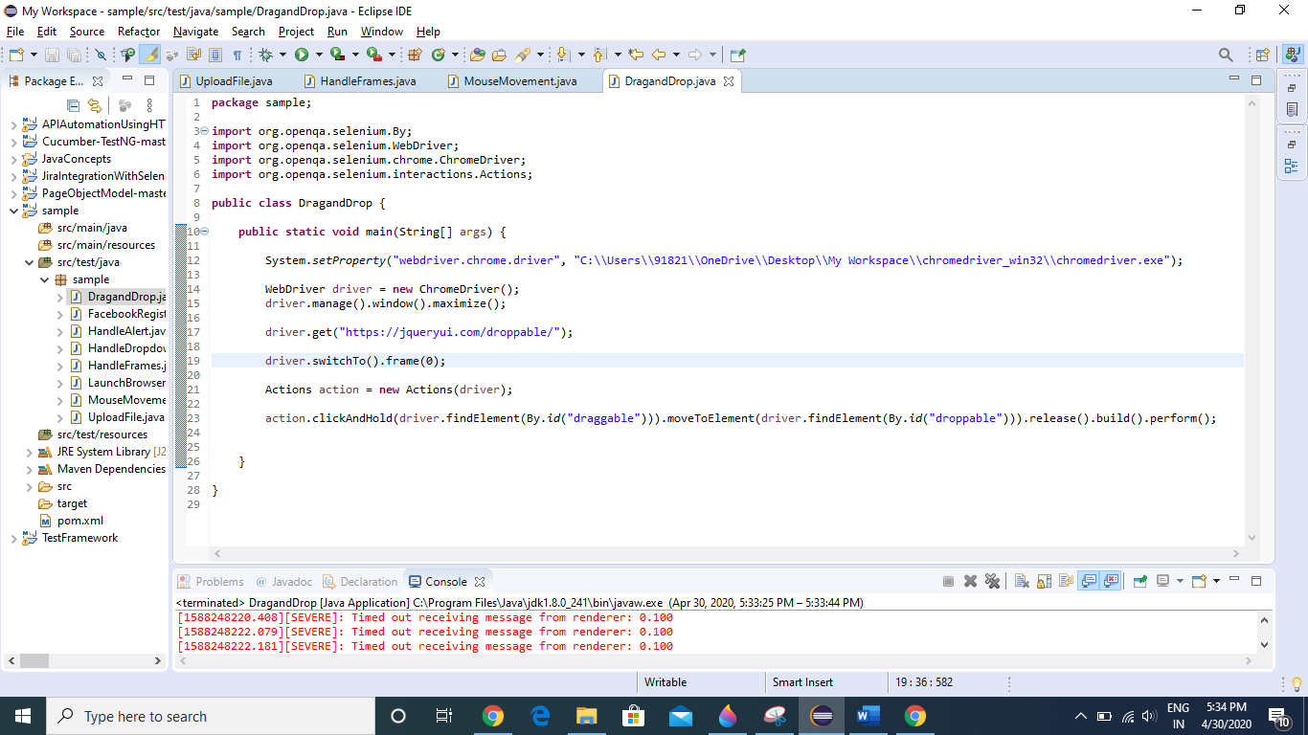

After executing the above code

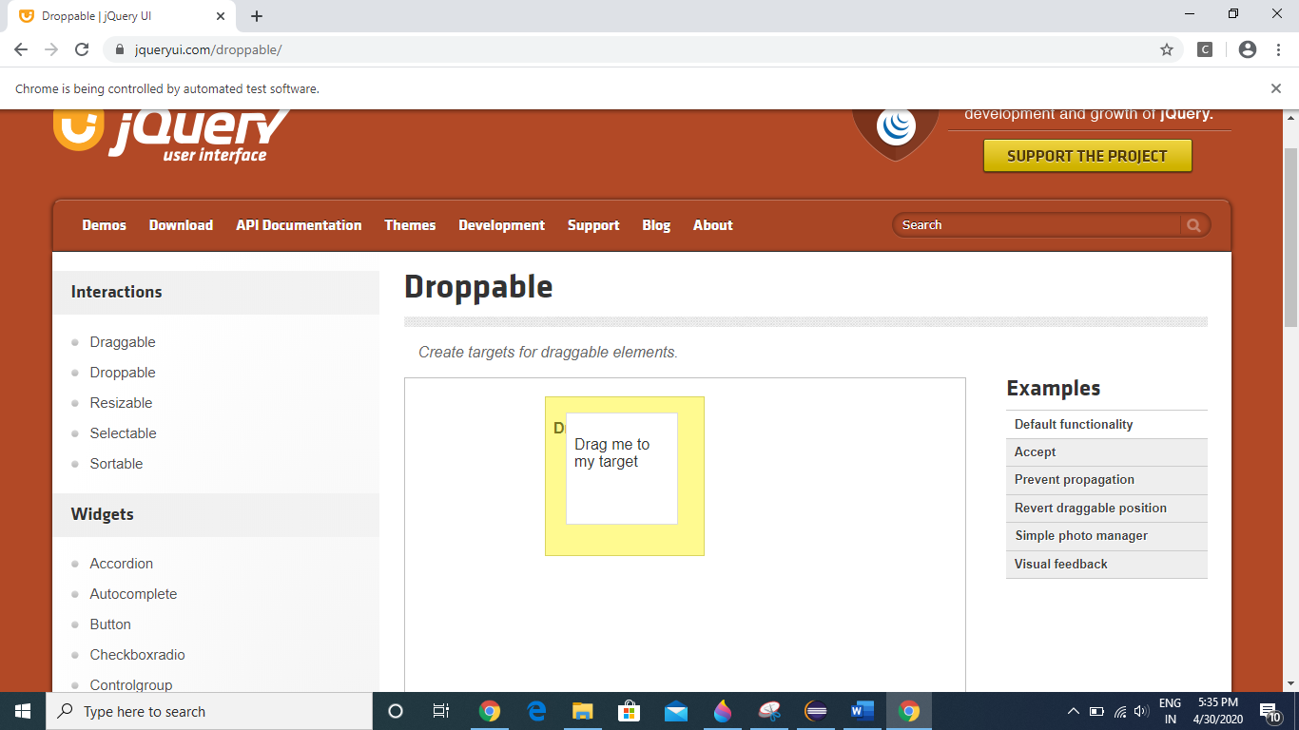

**Dynamic Wait**

* Page Load Timeout , Implicit Wait, Explicit Wait

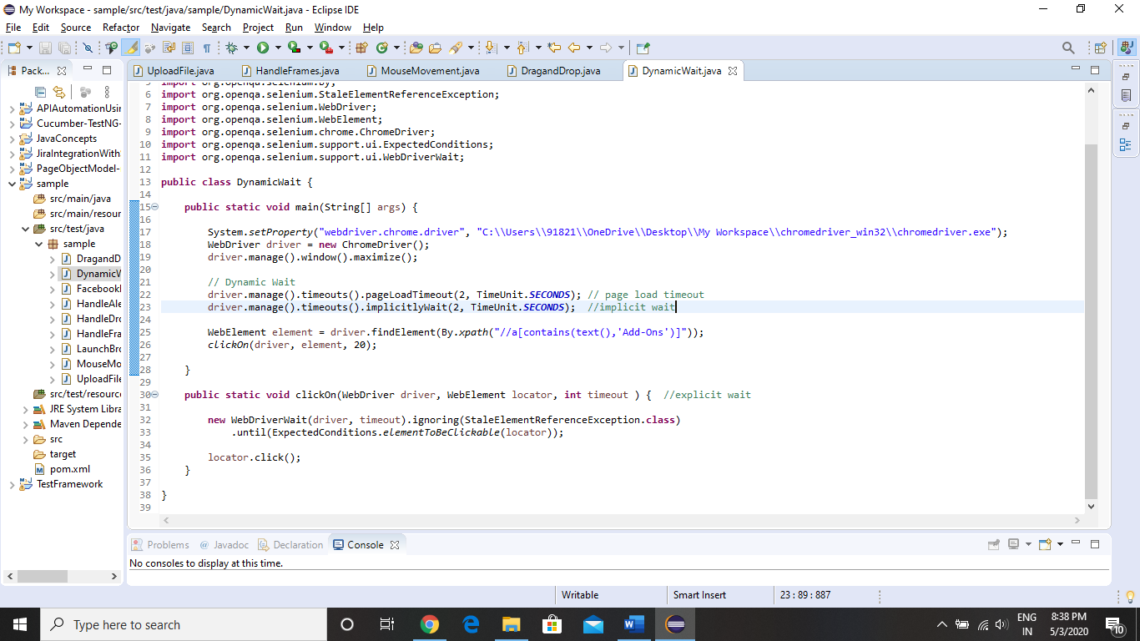

**Find Elements Concept**

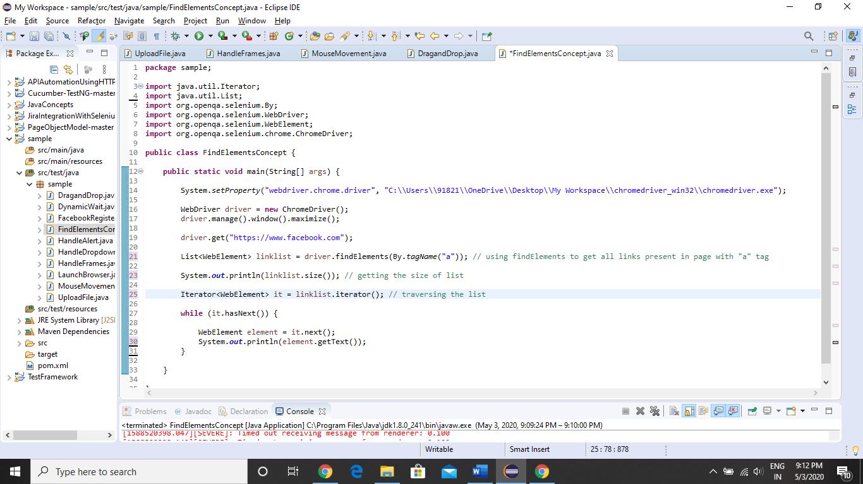 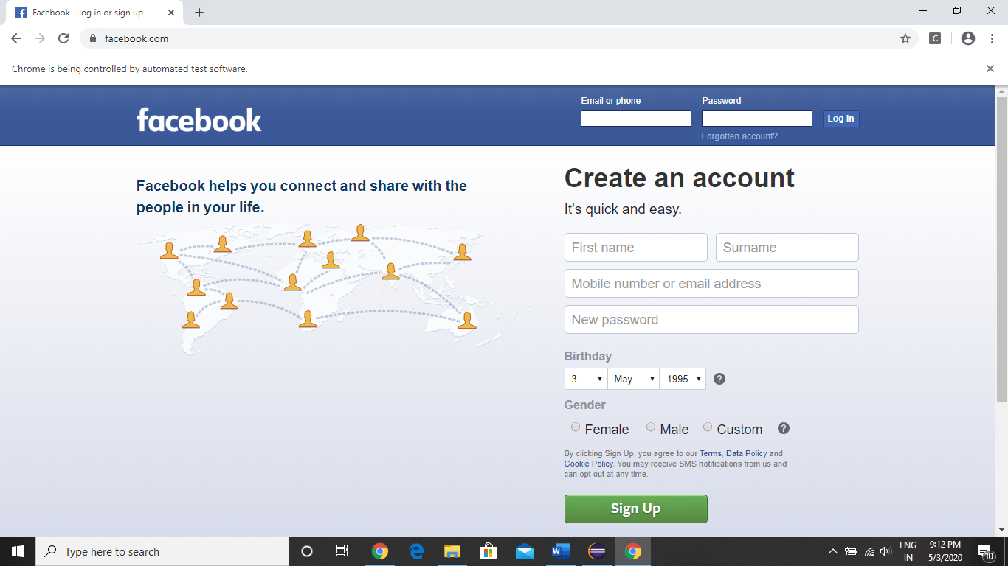

Here first we are getting the size of list (How many number of links with a tag in the webpage)

Then we are printing the name of all the links.